 | The Gases  How High Can You Fly? | Group Members____________________________  __________________________________________
 | Essential Questions  - How do gases make our daily lives better? | Objectives  - Determine the pressure needed to pop a stopper.  - Using the gas laws determine how much gas is needed to produce this pressure  - Using stoichiometry determine the amount of reactants needed to create your rocket.
Rocket are powered by the burning of fuel which causes the rapid expansion of gas, creating lots of pressure. In this simulation, how far can you get a rocket to travel using only baking soda (NaHCO₃) and vinegar (HC₂H₃O₂).
Part 1: Determine volume of the rocket in liters. Choose one of the two bottles for the body of the rocket. Once a style has been chosen you may not switch bodies.
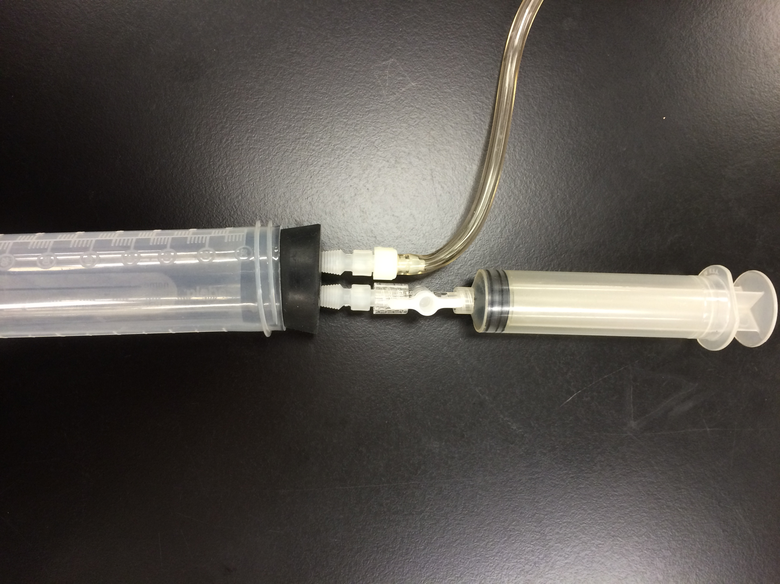
Vol of Bottle___________________________ Vol of Film Canister______________________________
Stopcock in open position
Part 1: How much pressure is required to pop the stopper? (5 pts)
- Turn on the labquest, make sure the pressure sensor is connected to channel one.
- Change the rate to 3 samples/s by clicking on the rate button.
- Insert the stopper connected to the pressure sensor into the open end of the baby bottle.
- Make sure the stop cock is open on the valve where the syringe is attached to the pressure sensor.
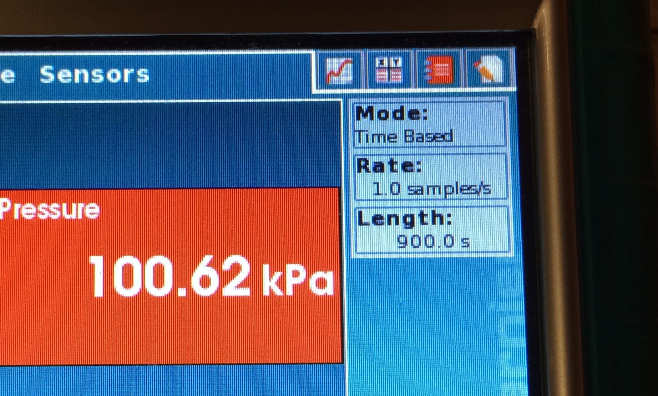
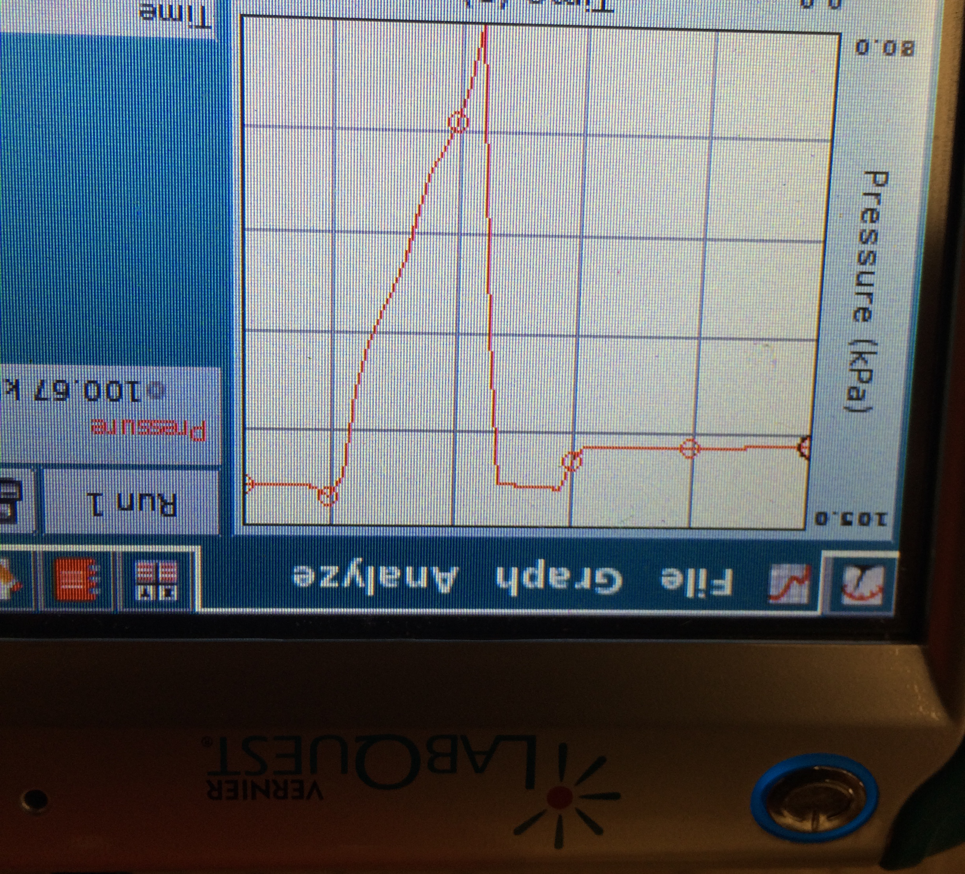
- Select graph and begin recording the pressure.
To create graph

Rate
To begin/stop data collection
- Making sure the stoppered end is pointing away from everyone and anything breakable, gently and slowly depress the syringe on the pressure sensor, the pressure should be increasing, until the canister pops off.
- Stop recording data.
- Record the highest pressure recorded based on the graph.
- Repeat steps 3-6 for 3 more trials.
Pressure 1 | Pressure 2 | Pressure 3 | Pressure 4

- Determine the average pressure and get signed off by your teacher.
Average pressure:

Teacher’s Initials____________
Part 2: Mols of Gas Needed
- Write a balanced equation for the reaction of baking soda and vinegar.

- Based on the average pressure, calculate the moles of gas needed to produce sufficient gas to launch your rocket. Get your mols of gas signed off. (5 pts)

Today’s temperature_________________.

Teacher’s Initials____________
Part 3: Reactants Needed For Launch
The volume of vinegar needed can be calculated using (mol CO₂/0.84)*1000 = mL vinegar
- One of the reactants is directly responsible for the creation of the gas. This will act as the limiting reactant. ___________________ is the limiting reactant.

- Determine the amount of limiting reactant needed in grams (baking soda) or mL (vinegar). Get the amount signed off. (5 pts)

Teacher’s Initials____________
- Determine the amount of excess reactant needed. Get the amount signed off. (5 pts)

Teacher’s Initials____________
Part 4: Launching the Rocket
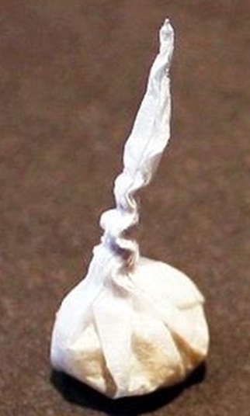
- Remove the plunger from the syringe and close the stop cock on the syringe.
- Measure out the volume of vinegar plus 2 ml in the syringe.
- If the syringe in not attached to the pressure sensor attach it to the stopper on the pressure sensor and insert the stopper into the body of the rocket.
- Obtain a tissue and separate the layers. Using a portion of one layer measure out the mass of baking soda required and twist into a little pouch.
- Read steps 6-9 carefully before doing, as this will need to occur in quick succession.
- Do NOT drop the little pouch of baking soda into the vinegar. Carefully place the pouch into the barrel of the syringe while keeping the tail hanging out and insert the plunger until it fits in the notch. (DO NOT push the plunger in all the way).
- Begin gathering pressure data on LabQuest.
- Position your rocket on the launching platform with the stopper hanging over the edge.
- Open the stopcock and wait for it to fire. Record the distance traveled in meters.
- Repeat 1-9 for a total of two trials.
- Repeat for two more trials, but double the mass of baking soda. Record below
 | Trial 1 | Trial 2 | Trial 3 | Trial 4
Mass of NaHCO₃
Distance
Pressure

Average distance travelled __________________________. Teacher’s Initials____________
Bonus: 0.25 pts/meter travelled not to exceed 2 pts

Post Lab Questions: Use complete sentences and proper English.
- Did the length the rocket travel vary with the amount of baking soda? Explain. (2 pts)

- Provide 2 good sources of error and how this effected the pressure. Explain. (4 pts)

- A group of students is attempting to launch a 1.00 liter rocket at 25.0°C. They have determined that 260. kPa is needed to launch the rocket. They have 7 gram of baking soda and 130 gram of vinegar. Will they be successful? Support the answer with calculations. (4 pts)

