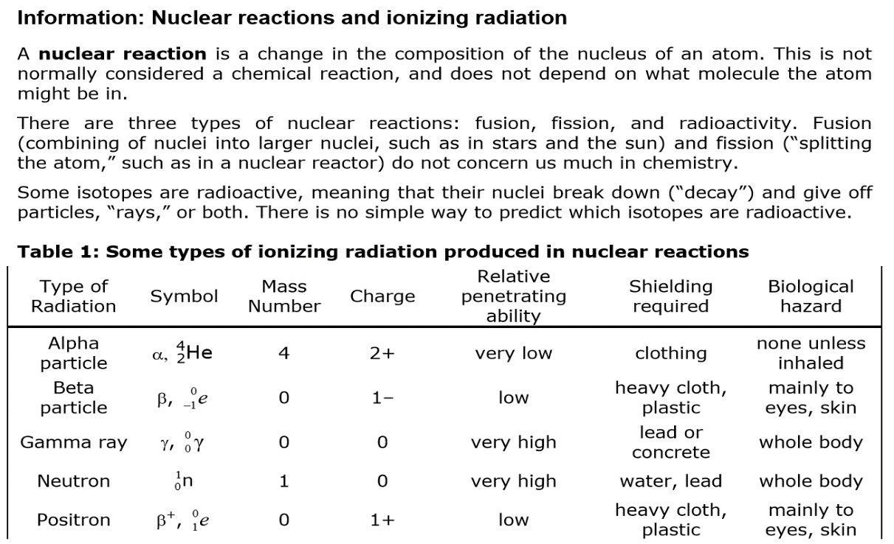

Balancing Nuclear Equations Practice

1. Complete the following nuclear equations in order to balance them. Identify the type of nuclear change represented by the equation.

Type of Nuclear Change











1. Write balanced nuclear equations for each process.

a). The alpha decay of radon-198.

b). The beta decay of uranium -237.

c). Positron emission from silicon-26.

d). Sodium-22 undergoes electron capture.

1. Write the overall nuclear equation for the decay of Po-210 if it undergoes 2 consecutive alpha

decays followed by a beta decay followed by another alpha decay. (Note: it actually occurs

stepwise, but this is a good lesson on how to put coefficients into nuclear equations.)

1. Write a balanced nuclear equation for the conversion of carbon-13 to carbon-14.
2. Write a balanced nuclear equation for the electron capture of thorium-235.
3. Write a balanced nuclear equation for the beta decay of selenium-75.
4. Write a balanced nuclear equation for the positron emission of rubidium-81.
5. Write the balanced nuclear equation for the alpha particle bombardment of einsteinium-238.

One of the reaction products is a neutron.

1. Write a balanced nuclear equation for the conversion of uranium-238 into californium-246 by bombardment with carbon-12.
2. Write a balanced nuclear equation for the alpha particle bombardment of plutonium-239. The

reaction products include a hydrogen atom and 2 neutrons.