Calorimetry and Specific Heat Lab

Objective: Review the concepts of energy, heat transfer, the law of conservation of energy, endothermic vs. exothermic processes, heat capacity and specific heat capacity. Learn how to calculate the amount of energy transferred from a burning puffed cheese snack (Cheeto) to water in a soda can and solve heat content and calorimetry problems.

Problem: Which type of Cheeto has the most Calories?

Materials:

Ring stand, iron ring Stirring rod Variety of Cheetos
Soda can Foil Candle lighter
Water Unwound paper clip

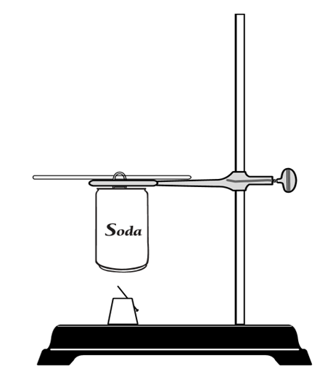
Procedure:

- Move your bags away from the lab tables.
- Place < 50 mL of water in the empty soda can, using the graduated cylinder. Record the volume of water with one uncertain digit.
- Weigh one Cheeto and record this mass.
- Mount the Cheeto on the foil and paper clip.
- Move the ring clamp so that the fire will *not* touch the bottom of the can, but will be close enough to heat the water through the can.
- Insert the temperature probe / thermometer into the water (not the can, the water!) and record its temperature.
- Set the Cheeto on fire and allow it to burn completely out. You may have to re-light.
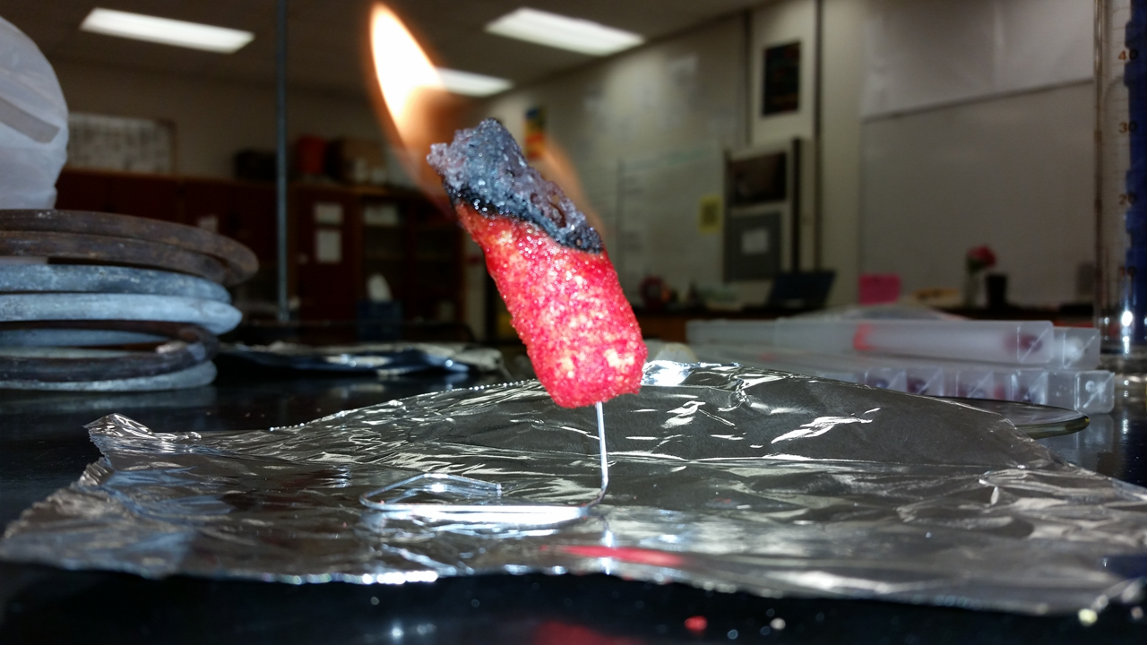
8. After it has burned out, record the
temperature of the water in the can.
CLEAN UP IMMEDIATELY (please don’t eat
the burned Cheetos).
9. Repeat for two more trials of the same
type of snack.
10. Look at the Cheetos bag and record the
data for the number of Cheetos per
serving and the number of calories per
serving.
Data: Cheeto Type: ________________________
Number of Cheetos per serving: ________________
Number of Calories per serving: ________________

 | Trial 1 | Trial 2 | Trial 3
Mass of one Cheeto (g)
Mass of water (g)
Initial temp. ($℃)$
Final temp. ($℃)$

Cheeto Type: ________________________
Number of Cheetos per serving: ________________
Number of Calories per serving: ________________

 | Trial 1 | Trial 2 | Trial 3
Mass of one Cheeto (g)
Mass of water (g)
Initial temp. ($℃)$
Final temp. ($℃)$

Calculations and Analysis: All work must be shown! Use sig fig rules and a unit after your final answer.
C of water = 4.184 J/(g.$℃$).

11. Calculate the average number of Calories in a serving of your first type of Cheeto.

 | Trial 1 | Trial 2 | Trial 3
Calculate $ΔT$of the water:
$ΔT$= T final - T initial
Calculate q of the water:
q = mC$ΔT$

What is the q of the Cheeto?
q Cheeto = - q of water
Calculate the number of Calories in the Cheeto.

4184 J = 1 Calorie
Calculate the number of Calories in one serving.

Calculate the average number of Calories in one serving.

12. Calculate your percent error for this Cheeto type. (You have the actual number of Calories per
serving from the bag.)

Teacher Initials: ___________ (10 points)
13. Calculate the average number of Calories in a serving of your first type of Cheeto.

 | Trial 1 | Trial 2 | Trial 3
Calculate $ΔT$of the water:
$ΔT$= T final - T initial
Calculate q of the water:
q = mC$ΔT$

What is the q of the Cheeto?
q Cheeto = - q of water
Calculate the number of Calories in the Cheeto.

4184 J = 1 Calorie
Calculate the number of Calories in one serving.

Calculate the average number of Calories in one serving.

14. Calculate your percent error for this Cheeto type. (You have the actual number of Calories per
serving from the bag.)

Teacher Initials: ___________ (10 pts)

15. In a complete sentence, compare the number of Calories per serving in each type of Cheetos you
burned. (2 points).

16. Describe how the different types of energy in the Cheeto are being transformed to warm the water
In the soda can. (2 points)

17. Describe the heat flow in this experiment using the terms “system”, “surroundings”, and “universe.” (2 points)

18. Is the burning of the Cheeto an endothermic or exothermic process? Are the changes in the
soda can endothermic or exothermic processes? Explain each answer. (2 points)

19. Predict which material has the higher specific heat capacity, air or water? How do you know? (2
points)

20. Describe AND EXPLAIN two sources of error that cause your calculated Calories/serving to be
different from that stated on the bag. (5 points)

