Don’t Flip Your Lid Lab
INTRODUCTION
The interaction of particles governs the physical world. The competing forces of attraction and repulsion between subatomic particles are responsible for properties that include size, ionization energy, and electronegativity. Between two atoms, those same forces influence the way valence electrons associate with each atom. Electrons can be transferred or shared to create a bond between two atoms. When electrons are transferred, the resulting ions are so strongly attracted to each other that they arrange themselves into a crystalline structure that maximizes those attractions. These interactions can all be understood qualitatively by Coulomb’s law. The force of the attraction, or repulsion, is related to the magnitude of the charges, q₁ and q₂, and the distance between the particles.
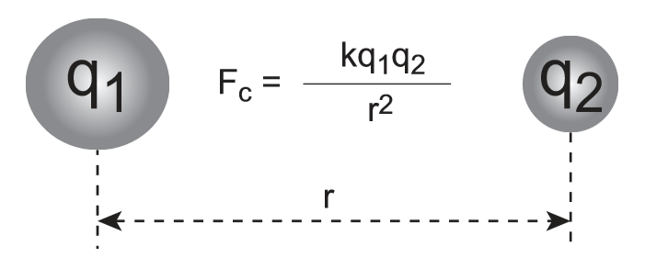
The same principle that holds cations and anions together also gives us a way to understand the physical properties of substances. In physical properties such as phase changes, collections of particles interact without any change in chemical composition. The nature of these interactions depends on a set of factors that influence the degree of Coulombic attractions between particles. Understanding these factors allows us to make informed predictions about the relative properties of pure substances, including the melting point.
PURPOSE
In this lab activity you will determine the relative melting points of four substances, paraffin, NaCl (table salt), C₆H₁₂O₆ (glucose) and iodine (I₂). Paraffin is a medium size nonpolar molecule, C₂₅H₅₂, NaCl is an ionic compound. Glucose is a medium size polar molecule, C₆H₁₂O₆, and Iodine, I₂, is a large nonpolar molecule.
MATERIALS

Hot plate – should be cold when you start Ring stand
Al foil Solid samples of: NaCl, C₆H₁₂O₆, C₂₅H₅₂, I₂

SAFETY ALERT!!! Wear your goggles. Do not inhale the iodine vapors. Allow the can lid to cool before dispersal

PROCEDURE
- In the space marked HYPOTHESIS, write a statement predicting in which order the salt, paraffin, iodine and glucose will melt.
- Set up your ring stand. Place the Al foil on the ring stand
- Transfer a small amount of each of the four samples into one of the four areas in a groove of the outer side of the foil. You only need a very small sample – just enough to be able to see the compound. The teacher will transfer the crystal of iodine.
- Turn the hotplate on and observe. You will need to record the relative order of melting. As soon as three of the compounds melt, turn off the hot plate.
- Allow the foil to cool before using tongs to dispose of it in a trash can or as your teacher directs.
- Answer the CONCLUSIONS questions.

HYPOTHESIS

DATA AND OBSERVATIONS: Record the relative order of melting for the four substances.

ANALYSIS

- In Table 1, write the names and formulas of the four substances from left to right in order of increasing strength of intermolecular forces. Identify the bond type as either covalent or ionic. Finally, complete the rest of the table for covalent molecules only.

Table 1: Properties of Four Substances
Name
Formula
Bond Type
Polarity
# Electrons
Intermolecular Forces

CONCLUSION QUESTIONS

- From what you know about attractive forces between molecules and/or ions, explain the relative order of melting points for EACH of the four substances. Consider bond type, relative strength, molecular polarity, electronegativity differences, polarizability, and the energy in J/mole required to melt the substance.

- In determining the strength of the intermolecular forces, it is important to consider the net forces present. Use this argument to defend why water, despite having hydrogen bonding, has a much lower melting point than paraffin.

- Hydrogen sulfide is a gas at room temperature, while water is a liquid, yet hydrogen sulfide has more electrons than water. Explain this anomaly.

- Consider the halogens at room temperature and 1 atmosphere of pressure. Why are fluorine and chlorine gases at room temperature, while bromine is a liquid and iodine is a solid?

