Empirical Formula of Magnesium Oxide Lab
Background: The empirical formula is the simplest whole-number ratio of numbers of moles of atoms in one mol of a compound. In this lab you will use your knowledge of empirical formulas to determine the formula for magnesium oxide.
SAFETY
- Use tongs at all times when handling the hot crucible and lid.
- Do not look directly at the burning magnesium. Avoid inhaling the fumes produced while heating.
PROCEDURE
- Clean and dry a crucible and lid and place them on a clay triangle as shown in Figure 1. To dry them, heat strongly for 1 to 2 minutes over the burner. Then let them cool to room temperature. CAUTION: Hot porcelain. Use tongs to handle the crucible and lid throughout the experiment.
- Record the combined mass of the crucible and lid in your data table.
- Polish a strip of magnesium ribbon with steel wool until it is shiny. Cut the strip into small pieces and place them in the crucible. Record the combined mass of the crucible, lid, and magnesium.
- Heat the covered crucible gently over the burner. Lift the lid about every 20 seconds to allow air in. CAUTION: Do not look directly at the burning magnesium metal. Avoid inhaling any fumes.
- When the magnesium appears to fully reacted, partly remove the crucible lid as shown in Figure 2. Continue heating for 1 minute.

- Turn off the burner. After the crucible has cooled to room temperature, carefully add a few drops of water to decompose any nitrides that may have formed. CAUTION: Use care when adding water. Too much water can cause the crucible to crack.
- Cover the crucible completely. Resume heating with the burner for 1 minute.
- Turn off the burner. Cool the crucible, lid, and contents to room temperature. Record the combined mass of the crucible, cover, and product.
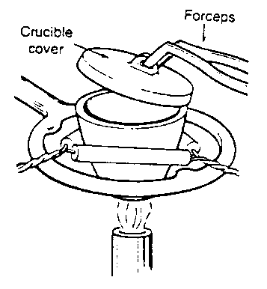
- Clean up your lab station. Discard the solid product in the designated waste beaker. Wash and towel-dry the crucible and lid.
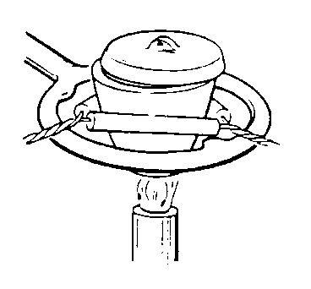

DATA
Construct a data table to display the measurements taken during the procedure. Make sure that each value is clearly labeled, including units. Use a ruler. Title your data table descriptively.

CALCULATIONS
Show all calculations and label all values.
- Use your data to calculate the mass of magnesium and the mass of oxygen in the product.

- Determine the empirical formula of the magnesium-oxygen product. When calculating the mole ratio, round to the nearest whole number. In book problems, you should multiply by 2, 3, etc. to get a whole number ratio. In this case, you need to round in order to compensate for experimental error.

- Use the masses from #1 to calculate the percent composition (%Mg and %O) of the product.

- The literature value for the %Mg in this magnesium-oxygen compound is 60.3%. Use this value to calculate the percent error of your experimental %Mg.

- Using your data calculate the theoretical yield for your magnesium-oxygen product, using the mass of magnesium ribbon you originally used.

- Using your data and the answer to number 5, calculate the actual yield and % yield for your product.

CONCLUSIONS
Write a conclusion based on your lab rubric.

QUESTIONS: Write this in complete sentences.

- Is your %Mg value too large or too small?

- What experimental errors (determinate or indeterminate) might specifically account for this type of deviation? (This requires some in-depth analysis of how errors in your original data would affect your final answer, causing it to be too large or too small. It often helps to work backwards through your calculations. Then, you need to think about what might have happened during the experiment to create these errors.

