FORENSIC GLASS ANALYSIS LAB

Glass analysis is a useful tool for a forensic scientist. Analysis may include examining glass fragments to determine the direction if impact, which will show from which side a window may have been broken. It may also include examining glass an determining its density or refractive index in an attempt to identify the type of glass, for example, from a car headlight or from a windowpane.

Glass is manufactured in different ways and for different purposes. Typical examples include:
- Soda-lime-silicate glass. This is most commonly used for flat glass, bottles, containers, and light bulbs.
- Borosilicate glass. This has a higher resistance to acid corrosion and is typically used for car headlights, Pyrex©, thermometers, and laboratory glassware.
- Alumino-silicate glass. This is more thermal resistant and is used in laboratory glassware, glass fibers, and stovetop cookware.
- Lead-alkali-silicate glass. More commonly known as lead crystal, this glass is used for decorative glassware and neon signs.

Exercise I – Comparing Glass Densities

Safety

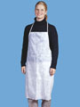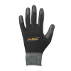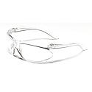

MATERIALS

Glass samples
25-mL graduated cylinder
Balance

PROCEDURE

- Place your glass sample onto a balance and determine the mass to the nearest 0.01 g.
- Record the mass in the table below.
- Repeat for each of the glass samples.
- Fill a 50-mL beaker half full and place it on the balance. Tare the balance.
- Place your glass sample into a graduated cylinder of water. The water amount used each time needs to be the same exact amount.
- Record the volume, which is the amount of water displaced by the sample.
- Repeat steps 4 through 6 for each glass sample.
- Now calculate the density of each sample using the formula.

Density = mass ÷ volume

SAMPLE | MASS (g) | VOLUME (mL) | DENSITY (g/mL)
Exercise II – Glass Fracture Analysis

When sufficient force is applied to a piece of glass, it will break. The initial point at which it breaks is known as a radial fracture. As the glass moves outward, secondary breaks, known as concentric or tangential fractures, appear.

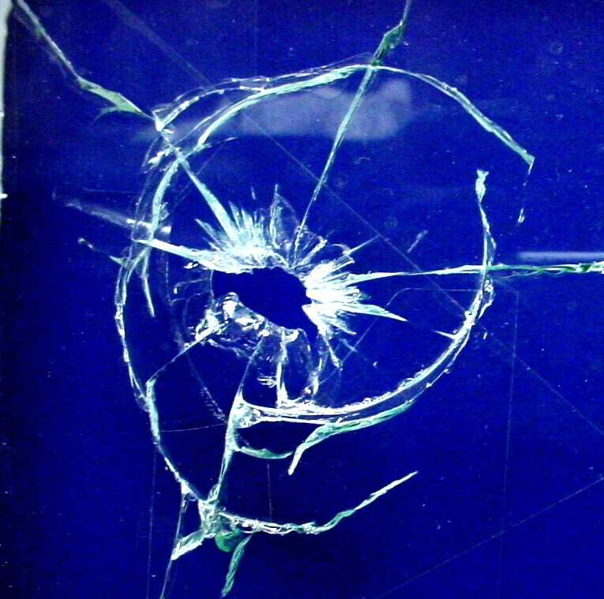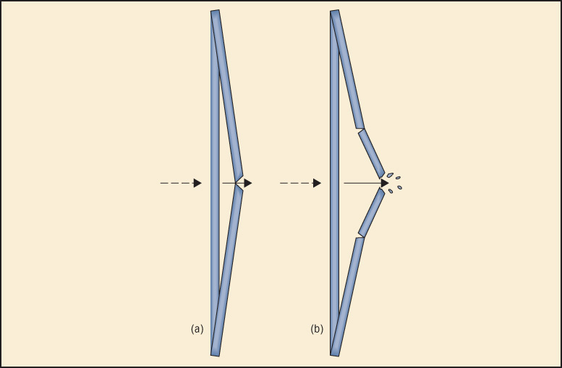
Figure 1 Figure 2
Radial and concentric fractures Radial and concentric fractures (a) radials are
formed first, from the side opposite the direction
of force. Next, concentric fracture (b) form on the
same side as the force.

Safety

MATERIALS

Glass pane
Marker
Nail
Packaging tape

PROCEDURE

- Take a small pane of glass and in the middle draw a picture one side using a marker.
- Using packaging tape, tape the glass on both sides.
- Place a nail in the center of the picture and tap lightly.
- Once the glass is broken, examine the edges with a hand lens. You may remove some of the tape carefully to observe. Examine the direction of the force using the 3R rule:
The ridges on Radial cracks are at Right angles to the Rear

Figure 3
Edge view of a radial fracture in a piece of glass. Arrow indicated direction of force.

DENSITIES OF GLASS

Some typical values for your expected measurements are listed below.

Lead-alkali silicate (lead crystal): 2.65 – 3.0 g/mL
Soda-lime silicate (flat glass): 2.41 – 2.63 g/mL
Window: 2.46 – 2.49 g/mL
Auto glass (not headlights): 2.53 – 2.75 g/mL
Porcelain: 2.3 - 2.5 g/mL
Pyrex: 2.26 – 2.39 g/mL
Borosilicate (car headlights): 2.20 – 2.29 g/mL

REFRACTIVE INDEX (RI)

LIQUID | RI | GLASS | RI
Water | 1.333 | Vitreous silica | 1.458
Olive oil | 1.467 | Headlight | 1.47–1.49
Glycerin | 1.473 | Window | 1.51–1.52
Castor oil | 1.482 | Bottle | 1.51–1.52
Clove oil | 1.543 | Optical | 1.52–1.53
Bromobenzene | 1.560 | Quartz | 1.544–1.553
Bromoform | 1.597 | Lead | 1.56–1.61
Cinnamon oil | 1.619 | Diamond | 2.419

Ziplock bags

- Pyrex
- Porcelain
- Basic glass – decorative
- Tempered
- Laminated
- Light bulb
- Glass – watchglass

