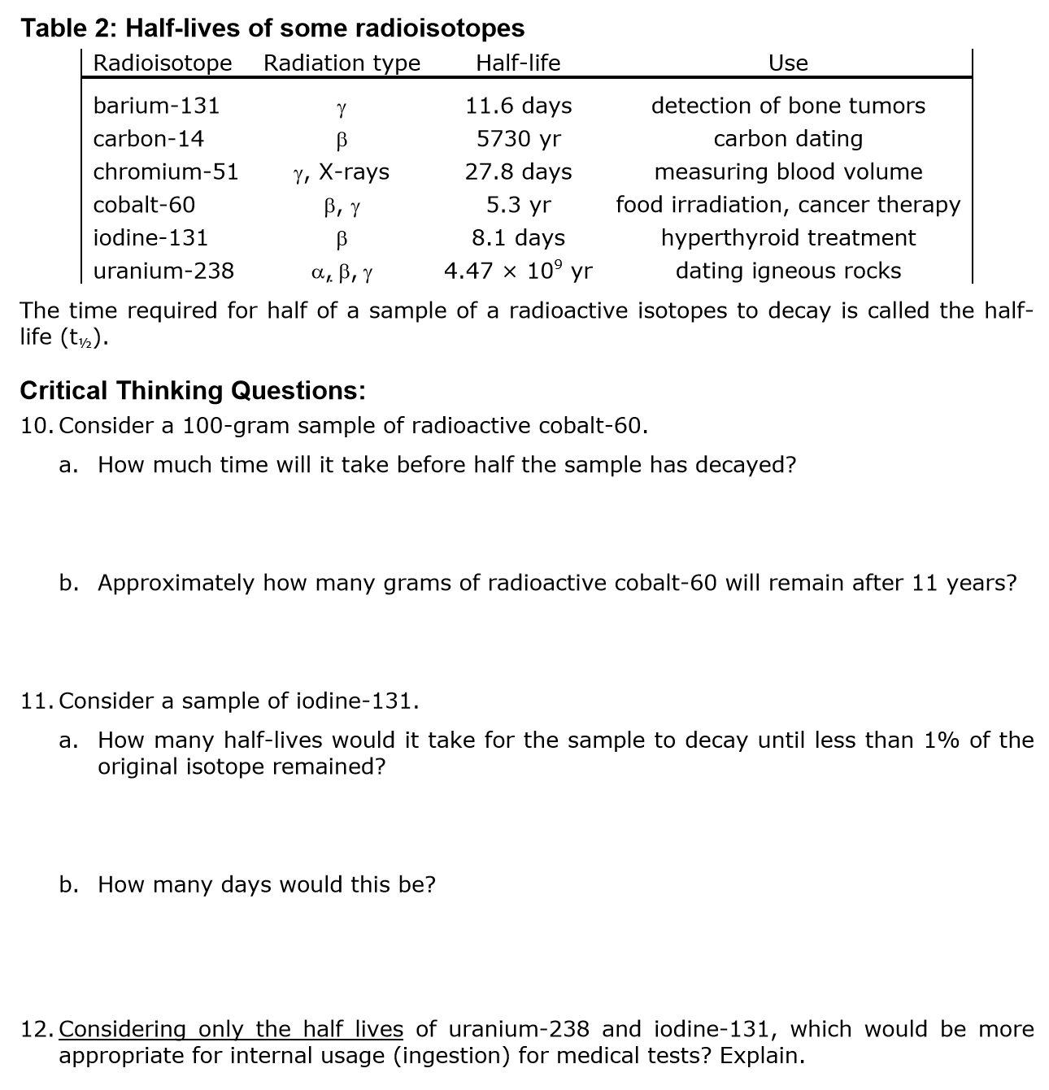

Practice Problems

The half-life of tritium (31H) is 12.3 years. If 48.0 mg of tritium is released from a nuclear power plant during the course of a mishap, what mass of the nuclide will remain after 49.2 years?

Technetium-104 has a half-life of 18.0 minutes. How much of a 165.0 g sample remains after 90.0 minutes?

Manganese-56 decays by beta emission and has a half-life of 2.6 hours.

A. How many half-lives are there in 24 hours?

B. How many mg of a 20.0 mg sample will remain after five half-lives?

A 20.0 g sample of thorium-234 has a half-life of 25 days. How much will remain as a percentage of the original sample after 90 days?

If gallium-68 has a half-life of 68.3 minutes, how much of a 10.0 mg sample is left after one half-life? Two half-lives? Three half-lives?

What is the half-life of the following substance?

