Lesson 4.2a Supplemental Notes
Engage/Explore: How Much Energy Do You Need to Melt Ice?
Objective: Calculate the “latent heat of fusion of ice” (symbol: H_{fus}). This quantity (measured in kJ /mil) is the amount of energy needed to melt 1 g of ice at 0°C.
Procedure:
- Place <50 mL of water into the beaker/ nested Styrofoam cups. Record the volume of the tap water and its initial temperature.

- Leave the thermometer in the cup. Obtain ice, and dry some of the cubes off with paper towel. Use the paper towel to place them into the nested Styrofoam cup, enough to fill it completely.

3. As the ice melts, keep an eye on the temperature. As it drops, keep adding ice to ensure the cup stays full.

4. Once the temperature stays constant, immediately remove all of the ice (quickly!) from the water. Record the
final temperature of the water and melted ice in the cup.

5. Determine the mass of the water and melted ice in the cup. Hint: you don’t actually have to weigh it.

6. Determine the mass of the melted ice in the cup.

Data: Record your data here, then calculate the volume of the melted ice in the space below it.

Volume of tap water (mL)
Initial temperature of water (°C)
Final temperature of water + melted ice (°C)
Volume of tap water + melted ice (mL)

Volume of melted ice = ________________

Analysis: Figure out how to calculate the latent heat of fusion of ice, assuming that the heat in the
water is only used to melt the ice. Don’t forget, q = mCΔT. Here are some other hints:

- The tap water transfers heat to the ice. Assume that the ice absorbs that energy, and melts.
- The latent heat of fusion is calculated by dividing q _{melted ice} / mol _{melted ice}. (This gives you units of kJ /mol.)

Questions:

1. The accepted value for the latent heat of fusion of ice is 6.008 kJ /mol. Calculate your percent error.

- Is it true that the heat in the water is only used to melt the ice? How do you know?

- If you don’t dry the ice cubes before putting them in the tap water, your calculated H_{fus} value will be smaller than the accepted value of 6.008 kJ /mol. Explain why.
Explain: Reading about Phase Changes
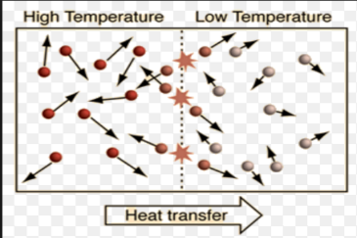
Right now you know how to calculate the heat (q) absorbed or released
by a sample of material if it is heated or cooled. You would use
q = mCΔT, because heating or cooling entails an increase or decrease in
the average kinetic energy of its molecules as they move faster or slower
in response. Heat moves because the moving molecules strike
each other, transferring energy.

When something undergoes a phase change, you cannot use q = mCΔT because the temperature STAYS CONSTANT, so you don’t have a ΔT term to use. It is not “heating” or “cooling” as it melts, freezes, vaporizes or condenses. The average kinetic energy of its molecules stays the same during the phase change. This is why it’s a big waste of energy to keep your stove on “high” after water is already boiling… the molecules won’t move any faster! Lower your dial after it’s reached 100℃… and the water will still keep boiling.

So if kinetic energy stays the same during phase changes… what does change? It’s the potential energy. The forces between molecules form, get stronger, break, or weaken. These intermolecular forces get weaker during melting and vaporizing, and stronger during freezing and condensing. While the phase change is going on, the molecules have the same kinetic energy during the entire process; thus, temperature stays the same.

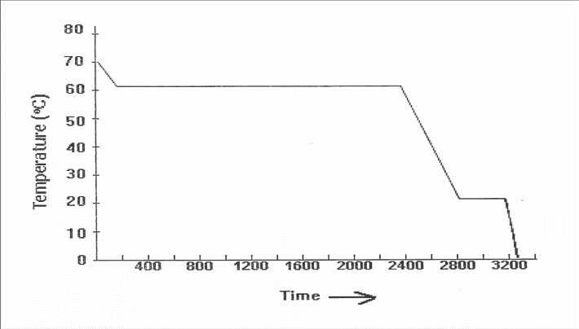
Cooling Curve

Supplemental Problems 1000 J = 1 kJ
3. How much energy in kilojoules is required to boil 75.0 mL of water currently held at 80.0℃? (175 kJ)

- How much energy (in cal) is lost by 50.0 g of steam as it cools from 120℃ to 80℃? (2.85 x 10⁴ cal)

- Suppose that you are camping in the winter. You have 30 g of ice at 0. °C that you need to melt and heat up for drinking water (40. °C). How much total heat (Joules) is needed to do this? (1.50 x 10⁴ J)

- 1.00 kg of ice held at – 5.00℃ is warmed, melts, and warms again to a final temperature of 25.0℃. How many kilojoules of energy must be absorbed? (782 kJ)

