|  |  |  |
| --- | --- | --- |
| http://image.slidesharecdn.com/chapter7kineticsandequilibrium-100415180947-phpapp02/95/chapter-7-kinetics-and-equilibrium-2-728.jpg?cb=1271355961Unit 5: How fast can a reaction go before it appears to stop? | | Name ______________________________  Date _______________________________ |
| **Essential Questions**   1. *Why do changes in temperature and concentration affect the rate of a reaction?* 2. Why do changes in temperature, reactant concentration, and product concentration affect the equilibrium point of a reaction? | **Vocabulary** *catalyst, chemical kinetics, mechanism, activation energy, rate-determining step, rate law, reaction, rate, rate constant, order, collision model, equilibrium, equilibrium expression, equilibrium constant, reaction quotient, Le Chatelier’s Principle* | **Objectives**   1. *Calculate the rate law* 2. *Determine the units for K* 3. *Write an equilibrium expression* 4. *Use the equilibrium to determine which side of the reaction is favored* 5. *Calculate the equilibrium constant or concentrations at equilbrium* 6. *Apply Le Chatelier’s principle to reactions* |

|  |  |  |
| --- | --- | --- |
| **Day** | **Topic** | **Homework** |
| 5.1 | How does temperature and concentration affect the rate of a reaction? | Watch the flip video over kinetics for next class. |
| 5.2 | What factors affect the rate of the reaction and how is rate determined. | Watch the flip video over equilibrium. |
| 5.3 | What is equilibrium? and practice problems | Watch the flip video over Le Chateliers |
| 5.4 | Le Chatelier’s Principle |  |
| 5.5 | Equilibrium Lab | Study |
| 5.6 | Unit 5 Exam |  |

**Lesson 5.2 Chemical kinetics** is the study of:

1. The rate at which reactants are converted to products during the course of a chemical reaction.

2. The factors, which include temperature, pressure, concentration, catalyst and surface area that affect the rate of a chemical reaction.

3. The sequence of steps, or the mechanism, which we believe occurs when reactants are converted to products.

The four factors that affect the rates of reactions are:

* Temperature - the rate of a reaction increases with increasing temperature.
* Concentration - the rate of a reaction increases with increasing concentration of reactants (pressure changes behave in the same way as concentration)
* Catalyst - the rate of a reaction increases with addition of a catalyst.
* Surface area - the rate of a reaction increases with increased surface area of the reactant.

We will look at the effects of temperature, concentration, and the addition of a catalyst.

*Collision Theory*

Collision theory says that for a reaction to happen two things must occur:

1. To react molecules must collide with sufficient energy to react - they must collide with enough kinetic energy to cause them to reach the activation energy barrier (**activation energy**).

2. The molecules must collide with the appropriate orientation for a reaction to occur.

In the following diagram, 2AB 🡪 A2 + 2B, two molecules of AB are trying to produce 1 molecule of A2 and 2 molecules of B. For this to happen again the molecules need sufficient energy and orientation.

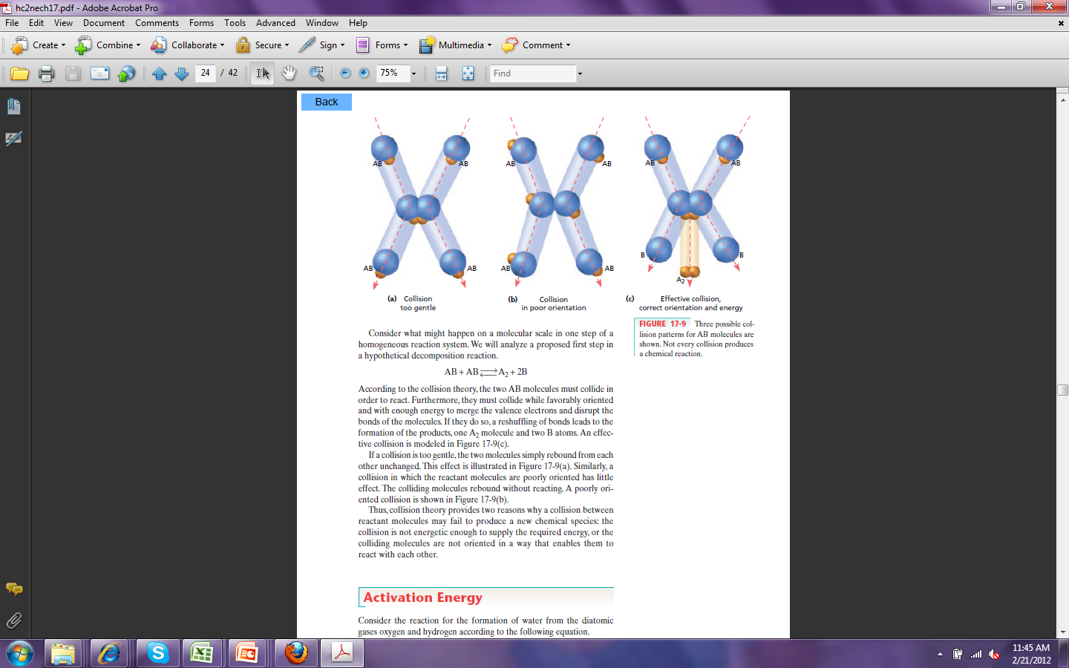

In example “a” there the molecules collide with the proper orientation but they do not have sufficient energy for the reaction to proceed. In “b” the molecules did not collide with the proper orientation, so even if there was sufficient energy, the reaction will not proceed. Finally in “c” the reaction proceeds because the molecules collide with the proper orientation and with sufficient energy.

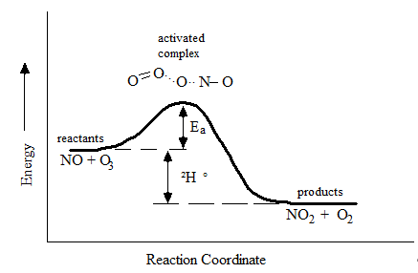The amount of energy needed is referred to as the **activation energy (Ea)**. This is the minimum amount of energy the molecules must have in order to form the activated complex. The activated complex can be thought of as an intermediary that is created during the process of the reaction. Think of the activated complex as a hill in mini golf. If you do not hit the ball with sufficient energy the ball will not make it to the hole, however if the ball is hit with sufficient energy it will travel over the hill and that hole in one is possible. The activation energy, Ea, represents a measure of the energy barrier colliding molecules must surmount if they are to react rather than to recoil from one another. It is assumed that every pair of molecules with energy less than Ea will not react and every pair with energy greater than Ea and the proper orientation will react. How can one ensure the molecules have sufficient energy to overcome the activation energy?

ΔH

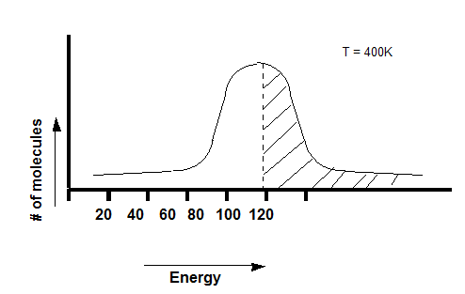*How does temperature affect the reaction rate?*

Molecules have a range of energies that can be described by an energy distribution diagram. Notice that it has a bell shaped curve, and most of the molecules have an average of 120 kJ/mol, although some have more and some have less. If the reaction we're discussing has an Ea of 120 kJ/mol, then about half of the molecules will have enough energy to reach the activated complex, therefore half of collisions will be effective with respect to energy.

Figure 1 Energy Distribution Diagram High Temp.

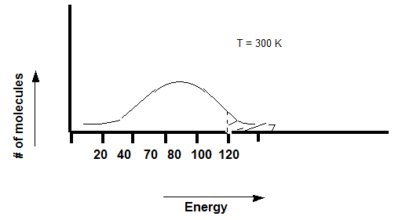If you lower the temperature, the curve flattens out, and the average energy of each molecule drops to about 90 kJ/mol. Thus, since our reaction has an activation energy of 120 kJ/mol, a smaller fraction of molecules will have enough energy to reach the activated complex.

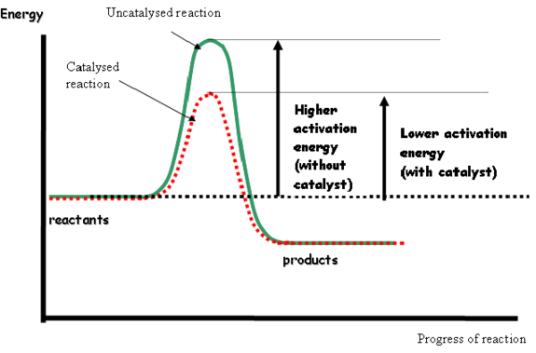

Figure 2 Energy Distribution Diagram Low Temp.

*How does a catalyst affect the rate of the reaction?*

If you recall from earlier a catalyst does not show up in the overall reaction but is rather consumed and then produced in a subsequent step. The purpose of a catalyst is to provide an alternate pathway for the reaction to proceed, which lowers the activation energy. As can be seen in figure 3 to the right.[1] With a lower activation energy more 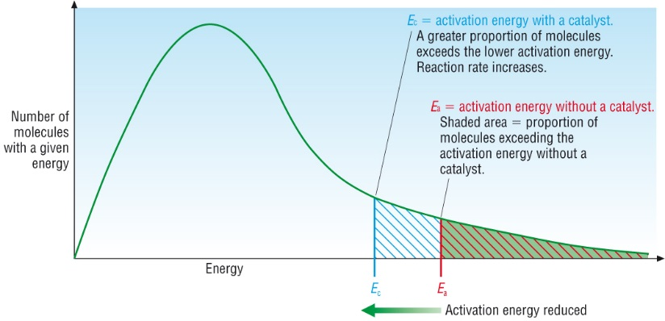molecules within the reaction will have sufficient energy to reach the activated complex and react. In figure 4[2] the molecules under the hump do not have sufficient energy to reach the activated complex. Only the fraction of molecules to the far right have sufficient energy. Once a catalyst is added, the fraction of molecules that have sufficient energy increases.

Figure 3 Catalyzed vs. Uncatalyzed Reaction

Figure 4 Number of Molecules Reaching the Ea

*How to Determine the Rate of a Reaction?*

Now that we have determined how temperature, concentration, and a catalyze affect the molecules in regards to forming the activated complex and having sufficient energy, how do we calculate the rate of a reaction?

For a chemical reaction, its rate, or rate of reaction, is expressed in terms of how fast the concentration, measured in molarity, of a substance changes in the course of the reaction.

Rate of reaction = 

or

Rate of reaction = – 

Notice the rates above only differ in a - sign. The rate must be positive, and because the change of your reactants is negative (final amount is less than initial), you must have a negative sign.

One symbol you must become familiar with is the **[ ]**. Brackets from here on out will mean "the concentration of” in molarity. Molarity, **M**, is mols of substance dissolved in liters of solution (mol/L).

Consider the following reaction:

2 N2O5*(g)* → 4 NO2*(g)* + O2*(g)*

The rate can be expressed the following ways, comparing the consumption of the product to that of the reactant. Again noting that the change in concentration of the reactant must be negative to ensure a positive rate. The below rates are expressed in terms of their stoichiometry. However when we determine the rate expression/equation, we cannot use the stoichiometry of the reaction.

rate = – = = 2

If we look at a general equation:

A(aq) + B(aq) 🡪 C(aq)

The rate of a reaction can be expressed by the following general equation, where A and B are the reactants. This is an example of the general form of a rate law.

rate = k[A]m[B]n

The exponents 'm' and 'n' represent the **order** of the reaction with respect to A and B. The orders are experimentally determined (they are not the stoichiometric coefficients) and show to what extend the concentration of the substance has on the rate of the reaction. If the order is negative, this means that that reactant retards the reaction. The higher the order the more effect that concentration will have on the rate. If the order with respect to a particular reactant is “0”, that reactant has no effect on the rate. The

|  |  |
| --- | --- |
| **Overall Order** | **Units** |
| 0 | $$\frac{M}{time}$$ |
| 1 | $$\frac{1}{time}$$ |
| 2 | $$\frac{1}{time (M)}$$ |
| 3 | $$\frac{1}{time (M^{2})}$$ |
| n | $$\frac{1}{time M^{(oveall order-1)}}$$ |

combination of m + n represents the overall order of the reaction. Again, order of a reactant is the positive or negative exponent, determined experimentally, of the reactant concentration in a rate law. The higher the order the more effect that concentration has on the rate of the reaction.

**k** is the **rate constant** in the mathematical equation. The units of k are dependent on m and n. The units of k follow the general formula $\frac{1}{time M^{(oveall order-1)}}$. Remember time can be measured and not limited to any of the following: seconds, minutes, hours….

The “rate” generally refers to the initial rate. The initial rate is the fastest rate of the reaction and occurs at the very beginning of the reaction. As a reaction proceeds the overall rate of the reaction begins to decrease due to the consumption of the reagents. At this point there are few competing reactions. It should be noted when using the initial rate the concentration of the reactants are initial concentrations. Only reactants that are aqueous or gaseous are included in the rate law.

**rate = k[A][B]**

The rate law can be determined using one of two methods: initial rates method or instantaneous rate method. We will focus on the initial rate method. If you would like to learn more about the other method take AP chem.

**Initial Rates Method**

Since rate is defined as – , the concentration of reacting species must be followed over time. Typically two experiments, each with different initial concentrations, are required. After collecting the experimental data, the initial rate is determined. The order of the reaction with respect to a particular reactant is obtained by comparing the ratio of the initial concentrations of the reactant with the ratio of their initial rates. In this method one of the reactants concentrations is held constant. Let’s to a problem together.

1. Consider the reaction and the following initial rate data.

2NO*(g)* + 2H2*(g)* **→** N2*(g)* + 2H2O*(g)*

Experiment PNO(mmHg) PH2(mmHg) Initial Rate ()

1 400 150 0.66

2 400 300 1.34

3 150 400 0.25

4 300 400 1.03

i) Determine the reaction order for NO and H2.

ii) Determine the overall order of the reaction.

iii) Write the specific rate law for the reaction.

iv) Determine the rate constant for the reaction (include units).

1. The following initial rate data were collected for the reaction:

2NO2*(g)* + F2*(g)* → 2NO2F*(g)* at 100 ˚C.

Exp. [NO2] [F2] initial rate (M/sec)

1 0.0482 M 0.0318 M 1.90 x 10–3

2 0.0120 M 0.0315 M 4.69 x 10–4

3 0.0480 M 0.127 M 7.57 x 10–3

i) Determine the reaction order for NO2 and F2.

ii) Determine the overall order of the reaction.

iii) Write the specific rate law for the reaction.

iv) Determine the rate constant for the reaction (include units)

1. For the reaction A + 3B + C → products and the following initial rate data.

Exp. # [A] [B] [C] Rate of formation of product

1 1.05 x 10-2 2.50 x 10-2 4.00 x 10-3 1.74 x 10-4

2 8.71 x 10-2 2.50 x 10-2 4.00 x 10-3 1.19 x 10-2

3 2.10 x 10-2 2.10 x 10-2 2.10 x 10-2 1.34 x 10-3

4 4.20 x 10-2 2.10 x 10-2 4.20 x 10-2 7.58 x 10-3

i) Determine the reaction order for A, B and C.

ii) Determine the overall order of the reaction.

iii) Write the specific rate law for the reaction.

iv) Determine the rate constant for the reaction (include units).

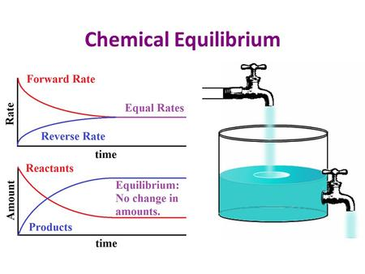**Lesson 5.3** **Equilibrium**

Figure 5Chemical Equilibrium

Typically a reaction is not a static state. Sometimes a reaction will proceed until it reaches completion that is that all of the reactants have been converted to products and the reaction can no longer proceed. However in many instances the reaction is dynamic and it reaches a state of **equilibrium**. Chemical equilibrium is the condition reached, in a chemical reaction, when the concentration of reactants and products no longer change, or are constant. This condition is attained when the rates of the forward and reverse reactions are equal as seen in fig 5[3]. The reaction appears static, but at the molecular level it is dynamic. A reaction written with a **double arrow** is at equilibrium. An equation can be written to express the position of equilibrium and is referred to as the **equilibrium expression**. What is meant by the position of equilibrium is that sometimes when equilibrium is established there will be more reactants in solution than products, meaning equilibrium favors the reactants, or it can favor the products meaning there are more products in solution than reactants. There are times when equilibrium falls right in the middle. The general form of an equilibrium expression is eqn 1. Eqn 2 is equilibrium with respect to concentration and eqn 3 is equilibrium with respect to partial pressures.

aA*(aq)* + bB*(aq)* cC*(aq)* + dD*(aq)*

Keq = Kc =

eqn 1 eqn 2

The equilibrium expression can be written by taking the concentration of the products raised to their coefficients divided by the concentration of the reactants raised to its coefficients all equal to **K**. Just like in kinetics only substances that are aqueous or gaseous will show up in the equilibrium expression. In the above expression the [ ]s again mean the molarity (concentration) of the solutions at equilibrium. Only amounts at equilibrium can be used in the expression. K is the equilibrium constant and is unitless. The value of K will help us determine whether or not equilibrium favors the reactants or the products. As we Kc is the equilibrium constant in which respect to concentration in terms of molarity. Depending on the type of reaction there are many different Kx – the x just lets us know this in the equilibrium constant in terms of x. For example, KP is the equilibrium constant in which the amounts of reactant and products are expressed in terms of partial pressures measured in atm or mm Hg. Ka is the equilibrium constant for an acid.

The equilibrium constant is a number whose value reflects whether the amount of products is greater or less than the amount of reactants at equilibrium. When K is >1, the amount of products is greater than reactants; the reaction favors products. When K is <1, the amount of products is less than reactants; the reaction favors reactants.

The equilibrium constant expression is the quotient of product equilibrium concentration to reactant equilibrium concentrations as determined by the balanced chemical equation.

The following reaction is at equilibrium at a particular temperature

H2*(g)* + I2*(g)* 🡨🡪 2HI*(g)*

1. Write the equilibrium expression for the above reaction.
2. Calculate of Kc for the above reaction given [H2]eq = 0.012 M, [I2]eq = 0.15 M and [HI]eq = 0.30 M.

50

Sometimes the concentrations and at equilibrium will not be known and it is necessary to calculate the equilibrium concentrations. The following tool will help us through the process. When initial concentrations are known we will use a **RICE** table to solve the problem. RICE stands for:

**R** reaction

**I** initial concentrations

**C** change in concentration

**E** equilibrium concentration

Let’s solve the problem below together.

1.00 liter container holds 1.06 moles of H2 and 1.57 moles of CO at a temperature of 162 °C. At this temperature, the following reaction occurs,

2H2*(g)* + CO*(g)* 🡨 🡪 CH3OH*(g)*

After equilibrium is established, analysis shows 0.200 moles of CH3OH in the container. Calculate the [CO]eq, [H2]eq and Kc.

Step 1: the initial concentrations need to be calculated. If you recall molarity (M) is mol/liter of solution.

[H2] =1.06 mol/L

[CO] = 1.57 mol/L

[CH3OH]i = 0.00 mol/L at the start of a reaction there is not product.

[CH3OH]f = 0.200 mol/L once equilibrium is established. Given in equation.

Step 2: set up RICE Table, include initial concentrations

|  |  |  |  |
| --- | --- | --- | --- |
| **R** | 2H2 | CO | CH3OH |
| **I** | 1.06 | 1.57 | 0.00 |
| **C** |  |  |  |
| **E** |  |  |  |

Step 3: determine the change in concentration. As the reaction proceeds the amount of the reactants is going to decrease by an amount, X, in relation to their stoichiometric ratios and products are going to be produced by an amount X, in relation to their stoichiometric ratios. Because H2 has a coefficient of 2 its change would be -2x.

|  |  |  |  |
| --- | --- | --- | --- |
| **R** | 2H2 | CO | CH3OH |
| **I** | 1.06 | 1.57 | 0.00 |
| **C** | -2X | -X | +X |
| **E** |  |  |  |

Step 4: determine the equilibrium concentration. The amount of reactant and product at equilibrium is the sum of I and C. Sometimes in problems an equilibrium concentration will be given. Because the equilibrium concentration of CH3OH is given in the problem we can determine X.

|  |  |  |  |
| --- | --- | --- | --- |
| **R** | 2H2 | CO | CH3OH |
| **I** | 1.06 | 1.57 | 0.00 |
| **C** | -2X | -X | +X |
| **E** | = 1.06 – 2X  =1.06 – 2(0.200)  =0.66 M | = 1.57-X  =1.57 – 0.200  1.37 M | = 0.00 + X  0.200 = 0.0 + X  X = 0.200 |

The equilibrium concentration for the above reactions is:

[H2]eq = 0.66 M [CO]eq = 1.37 M

The equilibrium expression is $Kc=\frac{{\left[CH_{3}OH\right]}^{1}}{{\left[H_{2}\right]}^{2}{\left[CO\right]}^{1}}$

$K_{c}=\frac{0.200}{{\left(0.66\right)}^{2}*1.37}$ Kc = 0.335

If an equilibrium concentration is not given in the problem, but the equilibrium constant is given the above procedure is followed except X would be included in your expression and the quadratic is used to solve for X.

$$x=\frac{-b±\sqrt{b^{2}-4ac}}{2a}$$

When using the quadratic to solve for the possibilities of X, one of the roots will result in a negative concentration at equilibrium. This root may be thrown out.

1. The equilibrium constant, Kc, for the reaction below is 33.3 at 760 °C. If 0.400 mol of PCl5 are placed in a 2.00 liter container, calculate the equilibrium concentrations of all species.

PCl5*(g)* <--> PCl3*(g)* + Cl2*(g)*

[PCl3]=0.199, [PCl5]=0.001, [Cl2]=0.199

1. The equilibrium constant, Kc, for the reaction

PCl5*(g)* <--> PCl3*(g)* + Cl2*(g)*

is 33.3 at 760 °C. If 0.400 mol of PCl5 and 1.0 mol of Cl2 are placed in a 2.00 liter container, calculate the equilibrium concentrations of all species.

[PCl3]=0.196, [PCl5]=0.004, [Cl2]=0.696

5. Kc = 19.9 for the reaction: Cl2 (g) + F2 (g) ↔ 2ClF (g)

Find the equilibrium concentrations of all species if the initial concentration of [Cl2] is 0.4M, [F2] is 0.2 M, and [ClF] is 7.3 M.

6. Kc = 170 at 298K for the following reaction: 2NO2 (g) ↔ N2O4 (g)

a) Suppose the initial concentration of NO2 is 0.015 M and the concentration of N2O4 is 0.025 M. Determine the equilibrium concentrations of all species.

7. Kc for the decomposition of ammonium hydrogen sulfide is 1.8 x 10-4 at 298K.

NH4HS (s) ↔ NH3(g) + H2S (g)

1. When the pure salt decomposes in a flask, what are the equilibrium concentration of NH3 and H2S?
2. If NH4HS is placed in a flask already containing 0.020 mol/L of NH3 and then the system is allowed to come to equilibrium, what are the equilibrium concentrations of NH3 and H2S?

*Changes in Equilibrium Position*

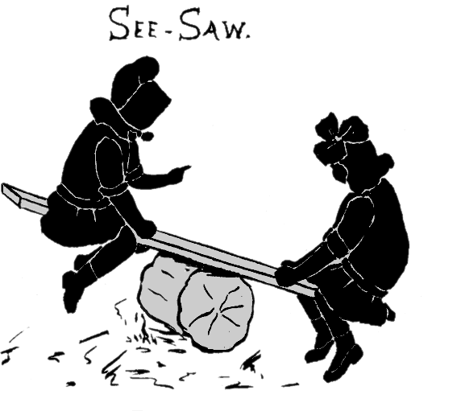**Le Chatelier's principle** states that if a system in equilibrium is disturbed by changes in temperature, pressure, and concentration of either the reactants or products, the system will tend to shift its equilibrium position so as to counteract the effect of the disturbance.[4] Think of the equilibrium state as a see saw that is always balanced. If the see saw becomes unbalanced, it is going to have to regain that balance by undoing the change. If the equilibrium shifts towards the reactants, this is referred to as a left shift. An equilibrium shift towards the products is referred to as a right shift.

*Three factors which can affect a reaction at equilibrium.*

**Concentration of a reactant or product**

When a system is at equilibrium, increasing the concentration of a reactant or product will cause the reaction to re-establish equilibrium by shifting the reaction in the direction, towards or away from the reactants, which relieves the stress. For example, in the simulation reaction,

A2*(g)* + B2*(g)* 🡨 🡪 2AB*(g)*

When the reaction is at equilibrium and the [B2] is increased the reaction proceeds from left-to-right to relieve the stress. When B2 is added the concentration of B2 increases moving the reaction away from equilibrium. To reestablish equilibrium the extra B2 needs to be consumed by producing more product. Therefore the reaction shifts towards the production of the product to relieve the stress, by trying to decrease the amount of B2. So the reactions proceeds from left-to-right. Similarly when the reaction is at equilibrium, addition of AB shifts the reaction from right-to-left (towards the reactants) to relieve the stress.

**Reaction volume or pressure (this only pertains to gaseous substances)**

To understand the effect of volume on a reaction, consider the following reaction.

PCl5*(g)* 🡨 🡪 PCl3*(g)* + Cl2*(g)*

Assume the reaction is at equilibrium in a sealed container. If the volume of the reaction container is lowered, molecules in the container are pushed closer together and the internal pressure increases. Think back to Boyle’s Law. To relieve this stress the reaction shifts in the direction to decrease the crowding of the molecules, the side with fewer moles of molecules. In the above reaction, it proceeds from right to left because the left side of the reaction has fewer gas molecules (1 mole) compared to the right (2 moles). Add up the coefficients to determine the number of moles on each side of the reaction.

If the volume is increased the reaction proceeds from left-to-right (towards the products). The increase in volume means there are fewer molecules per unit volume and the reaction proceeds in a direction to increase the number of molecules per unit volume and thus maintain constant pressure.

**Temperature**

To understand how temperature effects a reaction at equilibrium consider the equilibrium of NO2 and N2O4. Depending on what side of the reaction the heat is on treat it as a reactant or product. Because the heat is on the left – this reaction is endothermic.

heat + N2O4*(g)* 🡨 🡪 2NO2*(g)*

colorless orange-brown

When the reaction is cooled the color of the sample becomes lighter, indicating more N2O4*(g)* was formed. Heat is removed from the reaction system when the reaction is cooled. As the reaction is cooled it proceeds in the direction to offset the stress, in a direction to produce heat, from right to left. In general for endothermic reactions decreasing the temperature shifts the equilibrium towards the left and adding heat shifts the equilibrium to the right. It is just the opposite for exothermic reactions.

**To Sum It All Up**

|  |  |  |
| --- | --- | --- |
| **Stress** | **Shift** | **Why?** |
| Increase in concentration of a substance | **Away** from substance | Extra concentration needs to be used |
| Decrease in concentration of a substance | **Towards** decreased substance | Need to make more of what is lacking |
| Increase the pressure of the system | **Towards** *fewer* moles of gas | Need to decrease pressure by using up moles |
| Decrease the pressure of the system | **Towards** *more* moles of gas | Need to create pressure by making moles |
| Increase temperature of system | **Away** from heat  *exothermic* reaction is favored | Need to cool down system |
| Decrease temperature of system | **Towards** heat  *endothermic* reaction is favored | Need to heat up system |
| Add Catalyst | **No Shift** | Only speeds up the reaction |
| Add Solid Substance | **No Shift** | Does not change concentration of substance |

Consider the reaction below:

2H2S*(g)* +3O2*(g)*  🡨 🡪 2H2O*(l)* + 2SO2*(g)*

The heat of the reaction is ∆H = -1036 kJ. Given the reaction is at equilibrium, predict the direction the reaction will shift when the following stresses are applied:

i) the amount of H2O is increased

ii) the temperature of the reaction is increased

iii) the volume of the container is decreased

iv) the amount of H2S is decreased

**Practice**

For the following reaction:

5 CO(g) + I2O5(s) ↔ I2(g) + 5 CO2(g) ΔH= -1175 kJ

Predict the equilibrium shift and the effect on the indicated quantity for each change listed.

|  |  |  |  |  |
| --- | --- | --- | --- | --- |
|  | Change | Direction of Shift  (🡪; 🡨; or no change) | Effect on Quantity | Effect  (increase, decrease, no change) |
| A | decrease in volume |  | Kc |  |
| B | raise temperature |  | amount of CO(g) |  |
| C | Addition of I2O5(s) |  | amount of CO(g) |  |
| D | addition of CO2(g) |  | amount of I2O5 (s) |  |
| E | Removal of I2 (g) |  | amount of CO2 (g) |  |

In which direction will the equilibrium shift in response to each change, and what will be the effect on the indicated quantity?

Ni(s) + 4 CO(g) ↔ Ni(CO)4(g) ΔH = - 161 kJ

|  |  |  |  |  |
| --- | --- | --- | --- | --- |
|  | Change | Direction of Shift  (🡪; 🡨; or no change) | Effect on Quantity | Effect  (increase, decrease, no change) |
| A | Add Ni (s) |  | Ni(CO)4 (g) |  |
| B | Raise temperature |  | Kc |  |
| C | Add CO (g) |  | Amount of Ni (s) |  |
| D | Remove Ni(CO)4 (g) |  | CO (g) |  |
| e | Decrease in volume |  | Ni(CO)4 (g) |  |
| F | Lower temperature |  | CO (g) |  |
| g | Remove CO (g) |  | Kc |  |

Use arrows (up/down) to indicate the effect of each of these disturbances (stresses) on the concentration of the reactants and products in this equilibrium:

9KJ + 2SO2(g) + O2(g) ↔ 2SO3 (g)

|  |  |  |  |  |
| --- | --- | --- | --- | --- |
| disturbance | Effect on [SO2] | Effect on [O2] | Effect on [SO3] | Direction of shift |
| Decrease [SO2] |  |  |  |  |
| Increase [O2] |  |  |  |  |
| Increase [SO3] |  |  |  |  |
| Increase pressure |  |  |  |  |
| Decrease temp |  |  |  |  |

N2(g) + 3H2(g) ↔ 2NH3(g) + 100KJ

|  |  |  |  |  |
| --- | --- | --- | --- | --- |
| disturbance | effect on [N2] | effect on [H2] | effect on [NH3] | Direction of shift |
| Increase [N2] |  |  |  |  |
| Decrease [H2] |  |  |  |  |
| Increase [NH3] |  |  |  |  |
| Increase pressure |  |  |  |  |
| Decrease temp |  |  |  |  |

**More Equilibrium Practice**

1. Write an equilibrium expression for each of the following unbalanced reactions:
   1. PCl5 (g) **↔** PCl3 (g) + Cl2 (g)
   2. NH4HS (s) 🡨🡪 H2S (g) + NH3 (g)
   3. NH4NO3 (s) 🡨🡪 NH4+ (aq) + NO3- (aq)
   4. HCOOH (aq) + H2O (l) 🡨🡪 H3O+ (aq) + HCOO- (aq)
   5. Bi2S3 (s) 🡨🡪 Bi3+ (aq) + S2- (aq)
2. The equilibrium constant Keq for the following reaction is 11.5 at 300°C when the amounts of reactant and products are given in atmospheres. Suppose a tank initially contains PCl5 with a pressure of 3.00 atm and 300°C. What is the equilibrium pressure of chlorine gas.
3. An aqueous solution of ethanol and acetic acid, each with a concentration 0.810 M, is heated to 125°C. At equilibrium, the acetic acid concentration is 0.645 M. Calculate Keq at 125°C for the reaction.

C2H5OH (aq) + HC2H3O2 (aq) 🡨🡪 H2O (l) + CH3CO2C2H5 (aq)

Ethanol acetic acid ethyl acetate

1. The equilibrium constant for the following reaction

H2 (g) + I2(g) 🡨🡪 2HI (g)

is determined to be 57.85 at 450°C. If 1.50 mol of each reactant is placed in a 2.00 L flask at 450°C what are the concentrations of H2, I2, and HI when equilibrium has been achieved?

1. Ammonium hydrogen sulfide decomposes on heating.

NH4HS (s) 🡨🡪 H2S (g) + NH3 (g)

If Keq is 0.11 at 25°C when the partial pressures are expressed in atmospheres what is the total pressure in the flask at equilibrium?

1. The equilibrium constant for the dissociation of iodine molecules to iodine atoms is 3.76 x 10-3 at 1000K. Suppose 0.150 mol of I2 is placed in a 15.5 L flask at 1000K. What are equilibrium concentrations of all species present.

I2 (g) 🡨🡪 2 I (g)

1. Hemoglobin (Hb) can form a complex with both O2 and CO­. For the reaction

HbO2 (aq) + CO (g) 🡨🡪 HbCO (aq) + O2 (g) ­­

at body temperature, K is about 2.0 x 102. If the ratio comes close to 1.0, death is probable. What partial pressure of CO in the air is likely to be fatal? Assume the partial pressure of O2 is 0.20 atm.

1. Keq for the decomposition of ammonium hydrogen sulfide is 1.8 x 10-4 at 15°C.
   1. What are the equilibrium concentrations of NH3 and H2S when 5.00 grams of pure salt decomposes in a sealed 3.0 L flask at 15°C
   2. What are the equilibrium concentrations when 10.0 g of the pure salt decomposes in the sealed flask?
2. Lexan is a plastic used to make compact disks, eyeglass lenses, and bullet-proof glass. One of the compounds used to make Lexan is phosgene (COCl2), and extremely poisonous gas. Phosgene decomposes by the reaction

COCl2­ (g) 🡨🡪 CO (g) + Cl­2

for which Keq is 7.2 x 10-11 at 80°C. If pure phosgene at an initial pressure of 1.0 atm decomposes, calculate the equilibrium pressures of all species.

1. https://mypchem.wikispaces.com/Factors+Affecting+Rates+of+Reaction
2. http://www.chemguide.co.uk/physical/basicrates/catalyst.html
3. http://slideplayer.com/slide/4052282/
4. www.infoplease.com/encyclopedia/science/**le**-**chatelier**-**principle**.html