Unit 4 Major Quiz Problem-Based Review

These questions are purely calculation/problem based. This sheet is not sufficient review on its own. Be sure to *also* study the periodic table and relevant history, and check out the Kahoots for more practice.

- Analyze each isotope and fill in the chart.

Symbol-  Mass # | % Abundance | Mass of Atom | # protons | # electrons | # neutrons | Isotopic Notation
K-39 | 93.26% | 38.96 amu
K-40 | 0.01% | 39.96 amu
 | 6.73% | 40.96 amu | 19 |  | 22

2. Calculate the average atomic mass of potassium using the information in the previous
chart.

3. Europium has two stable isotopes, ¹⁵¹Eu (atomic mass 150.9198 u) and ¹⁵³Eu (atomic mass
152.9212 u). If the average atomic mass of europium is 151.97 u, what are the percent
abundances of each isotope?

4. To eject one electron from the surface of potassium metal, a potassium atom must absorb
2.3 eV in the form of a quantum.

- Calculate the wavelength, in nm, of this quantum.

- Calculate the frequency of this quantum.

- How much energy, in Joules, is required to eject a mole of electrons from the surface of potassium metal?

5. A photon of yellow light has a wavelength of about 570 nm.

- Calculate the frequency of yellow light?

- Does yellow light have sufficient energy to excite a hydrogen electron from its ground state of n = 2 to n = 5, which requires the absorption of 4.58 x 10⁻¹⁹ J?

6. Are these sets of quantum numbers allowable?

- 3, 1, -2, +½ b) 4, 2, -2, -½ c) 3, 2, 0, -½ d) 5, 6, -4, +1/2
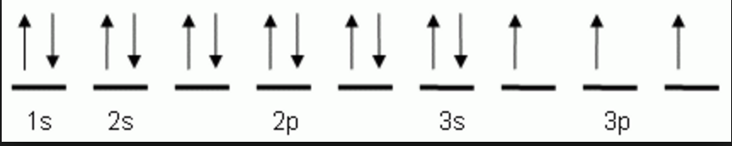

7. Write an allowable set of quantum numbers
for the indicated electron.
For the following questions, note that exceptions to the Aufbau order may exist.

8. Write the unabbreviated electron configuration for each element, determine their number of
valence electrons, and its valence energy level.

- F
- V
- Sn

9. Write the noble gas core electron configuration for:

- Nd
- Cd

10. Identify the element:

- [Ar] 4s¹3d¹⁰
- [Xe] 6s² 5d⁷

11. Are these atoms and/or ions isoelectronic? To prove this, write the configurations first.

- N³⁻ and Sc⁺³
- Kr and Se²⁻

12. Draw the noble gas core orbital notation for:

- Nb
- As
- Np
- Ag

13. Draw the noble gas core orbital notation - valence orbitals only - for:
- N b) Sb

