Unit 3 Nuclear Chemistry and Thermochemistry 2016-2017 Test Review

- Complete the following table:

 | Isotopic Notation | # of Protons | # of Neutrons | Mass Number | Element Name
a. | H
b. | Cl
c. |  |  |  |  | Silver-107

- Complete the following table:

Type | Definition | Mass | Charge | Penetrating Ability (energy)
Alpha (He)
Beta ()
Positron
(${}_{+1}^{0}e$)
Gamma (γ)

3. Radiation is streaming out of the lead box and between a positively and a negatively charged plate.
What type of particle is A________________, B_________________, C________________
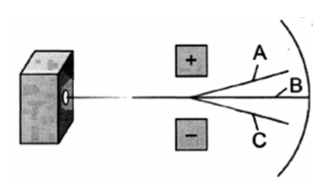

4. Write a nuclear equation for the alpha decay of:
  - Radium-226 b. Thorium-230

- Write a nuclear equation for the beta decay of:

  - Radon-231 b. Krypton-81

- Balance each nuclear equation. Identify the type of nuclear equation next to it.

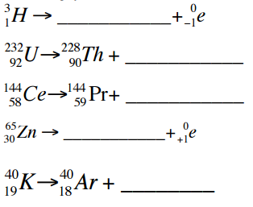
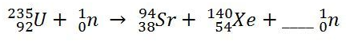
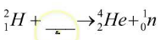
- The half-life of chromium-51 is 28 days. If you have 2.00 grams of chromium, how many grams would remain after 56 days?

- In the year 1992, a doctor’s office purchased 2 grams of Cesium-137 that registered 400 radiation counts per second (cps). Given the half-life of Cesium-137 is 30 yrs, how much radiation would be expected to remain by the year 2016?

- A 208 g sample of sodium-24 decays to 13.0 g of sodium-24 within 60.0 h. What is the half-life of this radioactive isotope?

- The half-life of protactinium-234 is 6.75 hours. What percentage of a given sample will remain after 27 hours?

- Compare nuclear fusion to nuclear fission, with regards to their definitions, the amount of energy they produce per mole, and their uses.

- When solid barium hydroxide octahydrate is mixed with solid ammonium chloride in a glass flask, the flask gets cold.
- Is the reaction absorbing or releasing heat?
- Is the reaction endothermic or exothermic?
- Why does the flask get cold?

- How much heat is released when 620 g of iron (C of iron = 0.444 J/g.°C) drops from 80.6°C to 46.2°C?

- A 16.5 g sample of a metal is warmed to 86.5°C and added to 50.0 g of 19.0°C water. The final temperature of the water is 20.7°C. What is the specific heat of the metal?

- What mass of 58.0°C iron must be added to 342 g of 23°C ethanol (C of ethanol = 2.46 J/g.°C) to make the final temperature of both come out to be 40.0°C?

- List the endothermic phase changes:

- List the exothermic phase changes:

- During a phase change why does the temperature stay constant?

Use the heating curve of water and the H_{fus}, H_{vap} and C values in your packet to answer questions #19 – 25.
- Between what two points does melting (fusion) occur for this substance?

- Between what two points is this substance in the solid phase? The liquid phase? The gas phase?

- Between what two points could the heat of vaporization for this substance measured?

- Which line segments on the curve show an increase in average kinetic energy? How about an increase in potential energy?
- How much heat was required to heat 50.0 grams of water from the lowest temperature on the graph to the highest temperature on the graph?

- How much heat in joules does it take to vaporize 0.5000 L of H₂O at 100.°C? (D_{water}=1 g/ml)

- How much heat in kilojoules is released when 12.90 mL of H₂O freezes at 0°C?

26. (Lab) For the heat of fusion of ice lab…what errors or occurrences would cause the calculated heat of fusion to be
larger than it should be? Smaller than it should be? How do they affect the calculation of the heat of fusion?
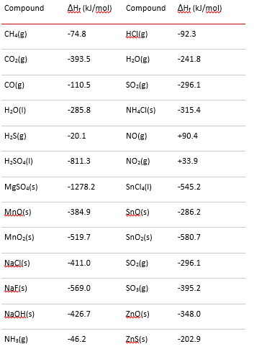
For questions #27-28, use this chart.
27. Calculate the ΔH°_{rxn} for each reaction:
a) 2 CO (g) + O₂ (g) 2 CO₂ (g)

b) MnO (s) + CO (g) Mn (s) + CO₂ (g)

28. Calculate the ΔH°_{f} of the chemical in bold given the
ΔH°:

a) C₃H_{8 (g)} + 5 O₂ (g) 3 CO₂ (g) + 4 H₂O (l)
ΔH°_{comb} = - 2220.1 kJ

b) 2 Na (s) + 2 H₂O (l) 2 NaOH (aq) + H₂ (g)
ΔH°_{rxn} = - 184 kJ

29. Given the following data:
N₂ (g) + O₂ (g) 2 NO (g) ΔH = + 180.7 kJ
2 NO (g) + O₂ (g) 2 NO₂ (g) ΔH = - 113.1 kJ
2 N₂O (g) 2 N₂ (g) + O₂ (g) ΔH = - 162.3 kJ
Use Hess’s law to calculate ΔH_{rxn} for the following reaction.
N₂O (g) + NO₂ (g) 3 NO (g)

30. Calculate ΔH for the reaction CH₄ (g) + NH₃ (g) --> HCN (g) + 3 H₂ (g), given:
N₂ (g) + 3 H₂ (g) --> 2 NH₃ (g) | ΔH = -91.8 kJ
C (s) + 2 H₂ (g) --> CH₄ (g) | ΔH = -74.9 kJ
H₂ (g) + 2 C (s) + N₂ (g) --> 2 HCN (g) | ΔH = +270.3 kJ
31. Calculate ΔH for the reaction 2 Al (s) + 3 Cl₂ (g) --> 2 AlCl₃ (s) from the data.
2 Al (s) + 6 HCl (aq) --> 2 AlCl₃ (aq) + 3 H₂ (g) | ΔH = -1049. kJ
HCl (g) --> HCl (aq) | ΔH = -74.8 kJ
H₂ (g) + Cl₂ (g) --> 2 HCl (g) | ΔH = -1845. kJ
AlCl₃ (s) --> AlCl₃ (aq) | ΔH = -323. kJ
32. (Lab) The following data chart is generated for a food calorimetry lab where a piece of food was burned and the
generated heat was released to a “soda can” type of calorimeter.

Mass of water (g) | 50.0 g
Initial temperature of water (degrees C) | 18.8 degrees C
Final temperature of water (degrees C) | 39.7 degrees C

a) Calculate the heat absorbed by the water.

b) How many joules of energy are contained in the burned food?

c) How many heat calories and dietary Calories are in the burned food?

d) What effect does each of these occurrences have on the calculated energy content of the food? Explain.
- Reading the final temperature of water as lower than the true value.
- Spilling water from the can after its volume was measured and before the experiment.
- There is open space between the burning food and the calorimeter.

