|  |  |  |
| --- | --- | --- |
| the_four_chemical_bonds_by_katyjsst-d6j8c5aUnit 6: Chemical Bonding and Nomenclature | | Name \_\_\_\_\_\_\_\_\_\_\_\_\_\_\_\_\_\_\_\_\_\_\_\_\_\_\_\_\_\_  Date \_\_\_\_\_\_\_\_\_\_\_\_\_\_\_\_\_\_\_\_\_\_\_\_\_\_\_\_\_\_\_ |
| **Essential Questions**   1. *Why is it important to have a systematic way of naming chemicals and writing formulas?* 2. *How do different chemical bonds drive the behavior of matter?* 3. *What can the shape of a compound tell us?* | **Vocabulary** *nomenclature, binary, chemical formula compound, ion, acid, base, ionic bond, covalent bond, metallic bond, sea of electrons, malleable, ductile, VSEPR, Lewis Structure, bond length, resonance, expanded octet, lone pair, percent composition, empirical formula, molecular formula* | **Objectives**   1. *Name covalent compounds, ionic compounds, acids, bases, and hydrates using IUPAC nomenclature rules* 2. *Distinguish and explain the differences in bonding and properties (ionic, covalent, and metallic)* 3. *Write the chemical formulas of ionic compounds, covalent compounds, acids, hydrates, and bases* 4. *Draw Lewis Structures and 3D optimize the structure of covalent compounds using VSEPR* 5. *Calculate the % composition of a compound.* 6. *Calculate to determine the empirical and molecular formula of a compound.* |

|  |  |  |  |
| --- | --- | --- | --- |
| Lesson | Description | Page | Homework |
| 6.0 |  |  | Complete Ionic Bonding Tutorial and Questions and simbucket.com |
| 6.1 | Ionic Bonding and Formula Writing | 3 | Complete Ionic Formula Tutorial and Questions on simbucket.com |
| 6.2 | Ionic Nomenclature | 5 | Complete Covalent Bonding Tutorial and Questions and simbucket.com |
| 6.3 | Metallic Bonding, Covalent Bonding and Nomenclature, and Acid Nomenclature | 9 |  |
| 6.4 | Practice Naming Everything |  | Study |
| 6.5 | Quiz  Lewis Structures with Exceptions | 15 | Complete Molecular Shapes Tutorial and Questions on simbucket.com. Use pp 20 for notes. |
| 6.6 | VSEPR | 21 |  |
| 6.7 | Percent Composition, Empirical and Molecular Formula | 25 |  |
| 6.8 | Empirical and Molecular Formula Lab |  |  |
| 6.9 | Review |  | Study |
| 6.10 | Exam |  |  |
| 6.11 | SLO |  |  |

**Common Ions Reference**

|  |  |  |  |  |
| --- | --- | --- | --- | --- |
| **1+ ions** | |  | **2 - ions** | |
| H+ | Hydrogen |  | O2- | Oxide |
| Li+ | Lithium |  | S2- | Sulfide |
| Na+ | Sodium |  | CO32- | Carbonate |
| K+ | Potassium |  | SO32- | Sulfite |
| NH4+ | Ammonium |  | SO42- | Sulfate |
| Ag+ | Silver |  | CrO42- | Chromate |
|  |  |  | S2O32- | Thiosulfate |
| **2+ ions** | |  | C2O42- | Oxalate |
| Mg2+ | Magnesium |  | O22- | Peroxide |
| Ca2+ | Calcium |  |  |  |
| Ba2+ | Barium |  | **3- ions** | |
| Zn2+ | Zinc |  | N3- | Nitride |
|  |  |  | P3- | Phosphide |
| **3+ ions** | |  | PO33- | Phosphite |
| Al3+ | Aluminum |  | PO43- | Phosphate |
|  |  |  | BO33- | Borate |
| **1- ions** | |  |  |  |
| H- | Hydride |  |  | |
| F- | Fluoride |  |  |  |
| Cl- | Chloride |  |  |  |
| Br- | Bromide |  | Variable Charge Metals | |
| I- | Iodide |  |  |  |
| NO2- | Nitrite |  |  | Greek/Latin Names |
| NO3- | Nitrate |  | Fe2+ | Ferrous |
| BrO3- | Bromate |  | Fe3+ | Ferric |
| ClO- | Hypochlorite |  |  |  |
| ClO2- | Chlorite |  | Cu+ | Cuprous |
| ClO3- | Chlorate |  | Cu2+ | Cupric |
| ClO4- | Perchlorate |  |  |  |
| IO3- | Iodate |  | Pb2+ | Plumbous |
| OH- | Hydroxide |  | Pb4+ | Plumbic |
| CN- | Cyanide |  |  |  |
| HCO3- | Hydrogen Carbonate |  | Sn2+ | Stannous |
| HSO3- | Hydrogen Sulfite |  | Sn4+ | Stannic |
| HSO4- | Hydrogen Sulfate |  |  |  |
| C2H3O2- | Acetate |  | Hg2 2+ (1+) | Mercurous |
| MnO4- | Permanganate |  | Hg2+ | Mercuric |

**6.1 and 6.2:  Bonding and Nomenclature of Ionic Compounds**

***A.  Properties of Ionic Compounds***

* Always solid at room temperature
* No conductivity when solid; conductive when dissolved in water, or molten - this varies by charge
* Very high melting points - this varies by charge
* Brittle, easily fractured and rigid, with a crystalline appearance

***B.  Ionic Bonding***

|  |
| --- |
| An **ionic bond** is a bond formed by the Coulombic **electrostatic force** of attraction between  oppositely charged metal and nonmetal ions. |

* The metal atom(s) has/have lower electronegativity so it donates all valence electron(s) to one or more nonmetal atoms, which have higher electronegativity.
* A metal atom becomes a positive ion (**cation**) in this process, and is now chemically stable because it will now have a full valence energy level.
* A nonmetal atom becomes a negative ion (**anion**) in this process, and is now chemically stable because it will now have a full valence energy level.  If the compound is **binary** (2 elements involved only) the ending of the atom’s name changes from -ine to -ide.
* Both types of ions will attain a **noble gas electron configuration** in this process.
* A **formula unit** is a single unit of an ionic compound.  The ratio of the cations to the anions in a formula unit is reflected in the ionic compound’s **chemical formula.**The cation is written first.
* An **ionic crystal** consists of several formula units of the same compound, and the ratio of the cations to the anions in the crystal are the same as in the chemical formula.

**Example:  Forming one sodium chloride formula unit   (ratio of cation to anion:  1:1)**

**Sodium cation          Chloride anion**

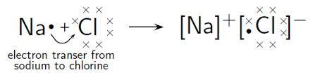

**Na+  = 1s2 2s2 2p6      Cl- = 1s2 2s2 2p6 3s23p6**

* The chemical formula of sodium chloride is NaCl, which reflects the cation:anion ratio of 1:1.

**Example:  One sodium chloride ionic crystal**

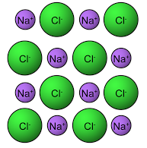

* This picture of a sodium chloride ionic crystal contains 8

formula units.

* The ratio of cations to anions is still 1:1, just like in the

chemical formula and in one single sodium chloride

formula unit.

* The ions repeat in a predictable pattern.  In 3D, this

repeating physical arrangement is called a **crystal lattice**.

**Example:  Magnesium chloride**

* 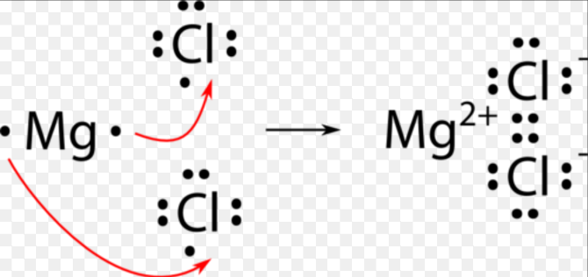One magnesium chloride formula unit

    contains one magnesium cation and two

     chloride anions.

* The chemical formula is MgCl2.
* In the ionic crystal, the ratio of cations to anions would also be 1:2.

When you draw representations of formula units, first draw one **Lewis electron-dot structure** for each element.  The number of valence electrons (dots) you draw is equal to the old-style Roman group number from the periodic table.  Draw them one at a time, north-south-east-west, before pairing them up (if necessary). Valence electrons always move from the metal to the nonmetal.

When done, every metal cation will have *no* dots, and every nonmetal anion will have

eight dots.  Place the symbol(s) each in their own square brackets and the charge on the outside, at the top right hand corner.   The resulting formula unit diagram is also called a Lewis electron-dot structure.  (Note:  this will look different for covalent compounds.)

Practice:   Draw the Lewis electron-dot structure for each element.

Strontium Boron Carbon Oxygen Iodine

Practice:  Draw the Lewis electron-dot structure for each formula unit, showing work as you do so.

AlBr3 K2O

between gallium and phosphorus between calcium and nitrogen

***C.  Explaining the Properties of Ionic Compounds***

* Solid ionic compounds do not conduct electricity because while in the solid form, the electrons are locked in place. The organized crystal lattice locks the ions in place, causing its rigidity.
* Dissolved or molten ionic compounds do conduct electricity because these states allow the cations and anions to move freely, permitting the free flow of charge.  The ions all physically separate from each other when dissolved or molten.
* Ionic compounds have high melting points because the electrostatic force of attraction between cations to anions is very strong and a lot of energy must be absorbed to overcome the attraction. The higher the charges = the stronger this force = the higher the melting point.  For example, MgO (Mg = +2, O = -2) has a higher melting point than NaCl (Na = +1, Cl = -1).
* Ionic compounds are brittle because applied force (from a hammer, for example) pushes the formula units up against each other.  Similar charges come into contact with each other and repel, causing fractures in the crystal lattice.

***D.  Ionic Compound Nomenclature and Formula Writing***

Every academic subject has essential vocabulary; for chemistry, a huge part of that vocabulary are ion formulas. To be successful at this skill, learn your ion formulas!  The ion chart at the front of the packet must be memorized. Luckily for you there are some tricks for memorizing the ions. Stay tuned for FITs on this topic. There is also a highly addictive game you can play that helps you memorize these ions. You can find it at [**http://www2.stetson.edu/mahjongchem/**](http://www2.stetson.edu/mahjongchem/).  (You’re welcome.)

First off, some basic vocabulary:

**Cu2+, P3- , Na+ and S2-** are examples of **monatomic ions**

**OH-** and **NH4+** are examples of **polyatomic ions** (all of whom are covalently bonded)

**Cu3P2** has three Cu+2 ions and two P3- ions and is a binary ionic compound

**NaOH**  has one Na+ ion and one OH- ion

**(NH4)2S** has two NH4+ ions and one S2- ion

i. Binary Ionic Compounds - **No** Transition Metals

Naming:

1. Metal cation retains its name. *• make sure ions join to form a* ***neutral*** *compound •*

2. The cation is always written FIRST! Do not change the cation name

3. For the nonmetal anion, remove the ‘ine’ ending’ and substitute ‘-ide’.

Formula writing:

1.  Note the charges of the cation and the anion involved.

       2.  Figure out the number of cations needed to cancel out charges on the anions.

3. The number of each ion is written as a subscript after that element symbol.

       4.  You may very well need multiple cations or anions to form your formula unit.

       5.  The ratio of cations to anions needs to be as low as possible.

6. Do not write subscripts as 1’s. Ever.

7. Do not write ion charges anywhere in the finished formula. Ever.

Examples: For each given name, write its IUPAC chemical formula, and vice versa.

CaF2 Rubidium nitride K2Te

NaS Aluminum oxide Magnesium arsenide

ii.    Binary Ionic Compounds - Transition Metals

Same as in part i), but many transition metals have variable charges.  Watch out!  *Special note:  The follow transition metals have only one charge (which you do have to memorize): Zn+2, Ag+1*

Naming:

4.  Write the cation charge as a Roman numeral and in parentheses.  Ex:  +3  = (III)  *The Exceptions* *are Zn and Ag - no Roman numerals or parentheses are required for them.*

       5.   Write this charge in *between* the name of the cation and the anion.

       6.   OR:  if using old-style Latin/Greek names for the cation, no ( ) are required.

Formula writing:

8.  If the old-style Latin/Greek name is used for the cation, remember the charge that goes with it.  -ic ending denotes the higher of the two possible charges, and -ous goes with the lower of the two possible charges.

Examples: For each given name, write its IUPAC chemical formula, and vice versa.

FeP Silver iodide ZnBr2

Cobalt (III) sulfide Cu3P2 Lead (II) oxide

Stannic fluoride Cuprous nitride PbF2 (use old name)

iii.  Polyatomic Ionic Compounds - With and Without Transition Metals

Several (covalently bonded) ions are polyatomic - this means that they have multiple elements in one ion. The vast majority of them are anions and have either an -ate or an -ite ending, meaning that they include oxygen in the ion.  (There are exceptions:  cyanide = CN-, and peroxide = O22-). Some have multiple parts to the name that reflect its structure.  The only polyatomic cation is ammonium, NH4+.

Naming:  Same as in parts i) and ii)

Formula writing:

7.  If you need >1 polyatomic ion to cancel out charges, enclose the formula in ( ) and how many ions you have after the parentheses.

8. If you only need one polyatomic ion to cancel out charges, do not use the ( ).

Examples: For each given name, write its IUPAC chemical formula, and vice versa.

Ammonium chloride ZnCO3

Ammonium nitrate Pb(SO3)2

Cesium chlorite (NH4)3PO3

Copper (II) hydroxide   AgHSO4

**6.1 and 6.2 Practice/Homework:**

1. Draw the Lewis electron-dot structure for each ionic formula unit.

Li2S between beryllium and sulfur

Mg3N2 between sodium and selenium

1. Write the IUPAC name for each formula, or vice versa.

sodium fluoride \_\_\_\_\_\_\_\_\_\_\_\_\_\_\_\_\_\_\_ K2S\_\_\_\_\_\_\_\_\_\_\_\_\_\_\_\_\_\_\_\_\_\_

zinc nitride \_\_\_\_\_\_\_\_\_\_\_\_\_\_\_\_\_\_ NaNO3    \_\_\_\_\_\_\_\_\_\_\_\_\_\_\_\_\_\_\_\_

magnesium oxalate \_\_\_\_\_\_\_\_\_\_\_\_\_\_\_\_ Na2CO3 \_\_\_\_\_\_\_\_\_\_\_\_\_\_\_\_\_\_\_\_

ammonium oxide \_\_\_\_\_\_\_\_\_\_\_\_\_ NH4C2H3O2 \_\_\_\_\_\_\_\_\_\_\_\_\_\_\_\_\_

copper (I) thiosulfate \_\_\_\_\_\_\_\_\_\_\_\_\_\_\_\_\_\_ Ni(CN)2 \_\_\_\_\_\_\_\_\_\_\_\_\_\_\_\_\_\_\_\_\_\_\_

cupric peroxide \_\_\_\_\_\_\_\_\_\_\_\_\_\_\_\_\_\_ Fe(NO2)2 \_\_\_\_\_\_\_\_\_\_\_\_\_\_\_\_\_\_\_

ferric sulfate \_\_\_\_\_\_\_\_\_\_\_\_\_\_\_\_\_\_\_\_ SnF2 \_\_\_\_\_\_\_\_\_\_\_\_\_\_\_\_\_\_\_\_\_\_\_

lithium chromate  \_\_\_\_\_\_\_\_\_\_\_\_\_\_\_\_ Al2S3 \_\_\_\_\_\_\_\_\_\_\_\_\_\_\_\_\_\_\_\_\_\_\_\_\_\_\_

magnesium hydroxide\_\_\_\_\_\_\_\_\_\_\_\_ (NH4)2SO3 \_\_\_\_\_\_\_\_\_\_\_\_\_\_\_\_\_\_\_\_\_\_\_

aluminum acetate \_\_\_\_\_\_\_\_\_\_\_\_\_\_\_\_ Ba(HCO3)2 \_\_\_\_\_\_\_\_\_\_\_\_\_\_\_\_\_\_\_\_\_\_\_

manganese (IV) chlorate \_\_\_\_\_\_\_\_\_\_\_\_\_\_\_\_\_\_ Cr(OH)3 \_\_\_\_\_\_\_\_\_\_\_\_\_\_\_\_\_\_\_\_\_\_

nickel (III) phosphide \_\_\_\_\_\_\_\_\_\_ Cu3(PO4)2 \_\_\_\_\_\_\_\_\_\_\_\_\_\_\_\_\_\_\_\_\_\_

1. Go memorize your ions.

**6.3: Metallic Bonding, Covalent Bonding, Nomenclature and Acids**

***A. Properties of Metals***

* Malleable, ductile, lustrous
* Conducts heat and electricity

***B. Metallic Bonding***

* A **metal** readily forms cations and has [metallic bonds](http://en.wikipedia.org/wiki/Metallic_bond)
* Metals lose electrons for chemical stability; form cations; and have low electronegativity.

**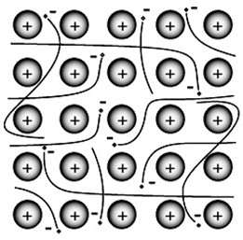**

In the metallic bond,

* The metal nuclei stay fixed in place.
* The valence electrons of all the nuclei drift freely from one nucleus to the other. This structure is called a “sea of electrons.”

The “sea of electrons” model explains the properties of metals in the following ways:

* The movable “sea of electrons” acts like a buffer or cushion between the nuclei, making the entire structure flexible and capable of being reshaped. (This explains malleability and ductility.)
* The freely moving, vibrating electrons reflect back incident light (explaining lustrousness) and allow electricity and heat to travel through the metal (explaining conductivity).

Different metals do not form chemical bonds with each other, but they do form homogeneous mixtures called **alloys**.

* Alloys have been made by humans since ancient times. Very few metals that you encounter are pure.
  + - Brass is an alloy of copper and zinc
    - Coinage and jewelry are alloys. (“10K”, “12K”, and “14K” are gold alloys.)
    - Sterling silver is an alloy of silver (92%) and copper (8%)
    - Stainless steel is an alloy of iron (81%), chromium (18%), nickel (1%), and trace amounts of carbon.
* Alloys are important because their properties are often superior to those of their component elements.
  + - Sterling silver is harder and more durable than pure silver, but still soft enough to make jewelry and tableware.
    - Brass is harder and easier to shape than either copper or zinc.

***C.* *Properties of Covalent Compounds***

* Not conductive – ever, no matter the state
* Can be any state at room temperature
* Generally insoluble in water (there are exceptions)
* If solid, may be waxy, soft and slippery (there are exceptions)

***D. Bonding of Covalent Compounds***

Covalent bonds between neutral, nonmetal atoms will form a single unit of a covalent (or molecular) compound. This single unit is called a **molecule**.

**A covalent bond is a bond formed by different nonmetal atoms sharing electrons in order to have a complete outer shell (or full valence energy level) and a noble gas electron configuration.**

Examples of covalent bonds are the bonds existing in H2, O2, H2O and CH4 (methane) molecules.

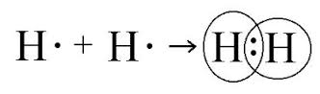**Examples of covalent bonding: (i) A hydrogen molecule (H2)**

* Hydrogen has 1 electron in its energy level.
* It needs to have two electrons to be stable (i.e. like He) so if it ‘bonds’ with another hydrogen atom and they both ‘share’ their electron with each other, it allows both atoms to have a noble gas electron configuration.

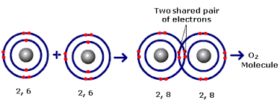**Examples of covalent bonding: (ii) An oxygen molecule (O2)**

* Oxygen has 6 electrons in its valence energy level.
* It needs to have 8 valence electrons to be stable (i.e. like Ne), and so if it ‘bonds’ with another oxygen atom and they both ‘share’ two of their electrons with each other, it allows both atoms to have a noble gas electron configuration.

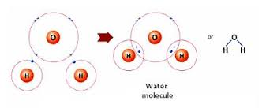**Examples of covalent bonding: (iii) A water molecule (H2O)**

* Hydrogen has 1 electron in its valence energy level.
* Oxygen has 6 electrons in its valence energy level.
* Oxygen can share 1 electron with one hydrogen atom and a second electron with a second hydrogen atom, which has the effect of allowing all atoms to have a noble gas electron configuration.

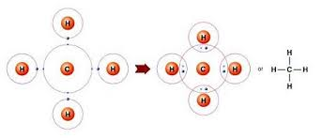**Examples of covalent bonding: (iv) A methane molecule (CH4)**

* Hydrogen has 1 valence electron.
* Carbon has 4 electrons in its valence energy level.
* Carbon can share 1 electron with each of 4 different hydrogen atoms, which has the effect of allowing all atoms to have a noble gas electron configuration.

One, two, or three pairs of electrons may be shared between two nonmetal atoms. In Lewis electron dot diagrams, a covalent bond is either represented by a pair of dots (one bond = 2 electrons), or a dash.

* A single (covalent) bond is when one pair is shared.
* A double (covalent) bond is when two pairs are shared.
* A triple (covalent) bond is when three pairs are shared.

It goes without saying that, of the three, a single bond is the weakest – it has the lowest bond energy. It also has the longest bond length. The triple bond is the strongest – it has the highest bond energy, and the shortest bond length.

***E. Explaining the Properties of Covalent Compounds***

A covalent bond, in and of itself, is actually very strong (think about how much energy is contained in gasoline) so the properties of covalent compounds are best explained in terms of the weaker forces existing *between* the molecules, not the covalent bonds *inside* the molecules. These weaker forces are called intermolecular forces, and will be explained better in Unit 7. For now, just know that

* Covalent bonds keep the shared electrons and participating atoms locked in place, so electricity cannot flow through a covalent compound in any state.
* If a solid covalent compound is soft, waxy, or slippery (like wax) the weak intermolecular forces are allowing the molecules to slip past each other. Liquid or gaseous covalent compounds have extremely weak intermolecular forces.
* If a covalent compound is insoluble it is because the uncharged molecules cannot separate from each other in water. The water would also be unable to break up a molecule.
* If a covalent compound dissolves in water (like sugar) it is because the molecules are separated *from each other* by the water.
* Molecules do not have full charges like ions do, so even if the covalent compound dissolves in water it still cannot conduct electricity.

***F. Nomenclature of Covalent (Molecular) Compounds***

**Big important note: Ionic compounds and covalent compounds have different types of bonds – so they have *different* naming systems!**

**NOTE**: The following are covalent compound formulas that MUST be memorized:

NH3 = ammonia

H2, N2, O2, F2, Cl2, Br2, l2 = hydrogen, nitrogen, oxygen, fluorine, chlorine, bromine, iodine

CH4 = methane

Naming and Formula Writing:

Covalent Naming Prefixes

1 – mono- 6- hexa-

2- di- 7- hepta-

3- tri- 8- octa-

4- tetra- 9- nona-

5- penta- 10-deca

1. The first nonmetal element retains its name.
2. The second element gets an **-ide** ending. (No -ates, -ites, etc.)
3. Use prefixes to identify the # of atoms.
4. The first element will NEVER get “mono-“.

Practice: Write the formula or the name for each covalent compound.

N2O = \_\_\_\_\_\_\_\_\_\_\_\_\_\_\_\_\_\_\_\_\_\_ SO3 = \_\_\_\_\_\_\_\_\_\_\_\_\_\_\_\_\_\_\_\_\_\_

carbon dioxide \_\_\_\_\_\_\_\_\_\_\_\_\_\_\_\_\_\_\_ BrF3 \_\_\_\_\_\_\_\_\_\_\_\_\_\_\_\_\_\_\_\_\_\_\_\_

carbon monoxide \_\_\_\_\_\_\_\_\_\_ XeF6 \_\_\_\_\_\_\_\_\_\_\_\_\_\_\_\_\_\_\_\_\_\_\_\_

***G. Acid Nomenclature***

The nomenclature of acids follow many unique rules. Acids are covalent, but they also all contain the hydrogen cation bonded to an anion. When gaseous, they follow the same naming and formula writing rules as all other covalent compounds; for example, HCl (g) is hydrogen chloride, and H2S (g) is dihydrogen sulfide. When aqueous (aq) or liquid (l), they have a different naming system altogether.

i. Binary Acids

Naming:

1. Use the hydro- prefix for hydrogen, then the root of the anion name attached to it.

2. Drop the ending on the anion name.

3. Change the ending on the anion to -ic**,** then add the word “acid. “

Examples: Hydrochloric acid Hydrosulfuric acid

HF (aq) H3N (aq)

ii. Acids with Polyatomic Ions, or Oxyacids

Naming:

4. Do not use the hydro- prefix for hydrogen. Ever.

5. If the anion name has an -ite ending, change it to -ous and add the word “acid.”

6. If the anion name has an -ate ending, change it to -ic and add the word “acid.”

Examples: H2CrO4 HNO2

H3PO4 HClO3

Perchloric acid Sulfuric acid

Carbonic acid Phosphorous acid

***H. Hydrates***

Hydrates are crystals that contain a number of “waters of hydration” locked into an ionic crystal structure. For every one formula unit of compound, there will be at least one “water” present; thus, you can extend this to mean that for every *mole* of compound, there will be at least one *mole* of “waters of hydration” present.

A common example of a hydrate is copper sulfate pentahydrate, which is used as an agricultural fungicide: its formula is CuSO4 **·** 5 H2O. For every one mole of copper sulfate, there will be five moles of water present.

Waters of hydration can be removed by heating the hydrate to let the water evaporate. After the water is driven off, you can refer to the salt as being “*anhydrous*” (without water).

Name the ionic compound as you would always do, then indicate the number of waters using a prefix, and add “hydrate”

Examples: MgSO4 • 3 H2O = \_\_\_\_\_\_\_\_\_\_\_\_\_\_\_\_\_\_\_

calcium phosphate tetrahydrate = \_\_\_\_\_\_\_\_\_\_\_\_\_\_\_\_\_

NaC2H3O2 • 2 H2O = \_\_\_\_\_\_\_\_\_\_\_\_\_\_\_\_

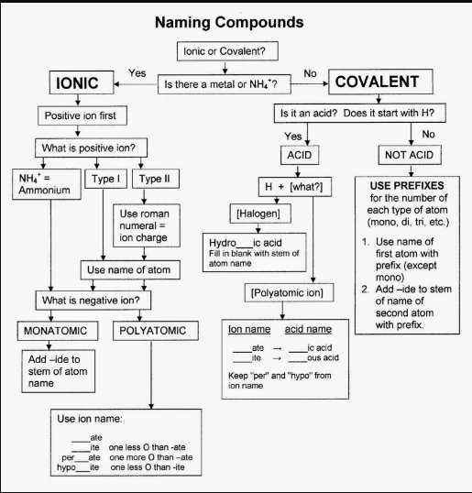­­

Type I: Ionic compounds that do not involve transition metals

Type II: Ionic compounds that involve transition metals

"ChemTeam: Chemical Nomenclature." *ChemTeam: Chemical Nomenclature*. N.p., n.d. Web. 20 Feb. 2017.

**6.3 Practice/Homework:**

1. Compare and contrast the structure and properties of an ionic bond to those of a metallic bond.

2. Use IUPAC rules to either name or write the formula for each compound.

Sulfur dioxide \_\_\_\_\_\_\_\_\_\_\_\_\_\_ Xenon trioxide \_\_\_\_\_\_\_\_\_\_\_\_\_\_\_

NF3 \_\_\_\_\_\_\_\_\_\_\_\_\_\_\_\_\_\_\_\_\_\_\_ P2S5 \_\_\_\_\_\_\_\_\_\_\_\_\_\_\_\_\_\_\_\_\_\_\_\_

Bromine pentafluoride \_\_\_\_\_\_\_\_\_\_\_\_\_\_\_\_ Disulfur dichloride \_\_\_\_\_\_\_\_\_\_\_\_\_\_\_

Hydrobromic acid \_\_\_\_\_\_\_\_\_\_\_\_\_\_\_ HI \_\_\_\_\_\_\_\_\_\_\_\_\_\_\_\_\_\_\_\_\_\_\_\_

phosphoric acid \_\_\_\_\_\_\_\_\_\_\_\_\_\_\_\_ H2C2O4 \_\_\_\_\_\_\_\_\_\_\_\_\_\_\_\_\_\_\_\_\_

carbonic acid \_\_\_\_\_\_\_\_\_\_\_\_\_\_\_\_\_\_ HClO \_\_\_\_\_\_\_\_\_\_\_\_\_\_\_\_\_\_\_\_\_

hydrophosphoric acid \_\_\_\_\_\_\_\_\_\_\_\_\_\_ H2SO3 \_\_\_\_\_\_\_\_\_\_\_\_\_\_\_\_\_\_\_\_\_

chlorous acid \_\_\_\_\_\_\_\_\_\_\_\_\_\_ HNO3 \_\_\_\_\_\_\_\_\_\_\_\_\_\_\_\_\_\_\_\_\_

zinc sulfate hexahydrate \_\_\_\_\_\_\_\_\_\_\_\_\_\_\_\_\_\_\_\_\_ Li2CO3­ • 5 H2O \_\_\_\_\_\_\_\_\_\_\_\_\_\_\_\_\_\_\_\_\_

sodium acetate pentahydrate \_\_\_\_\_\_\_\_\_\_\_\_\_\_\_\_\_ CuCl2**⋅**6 H2O \_\_\_\_\_\_\_\_\_\_\_\_\_\_\_\_\_\_\_\_\_\_\_\_\_\_\_\_\_\_\_

**6.5: Lewis Dot Structures with Exceptions**

A bond is the sharing of *2 valence electrons*. With only a few exceptions, atoms bond to achieve an octet and in doing so form a stable compound (2 or more different atoms) or a molecule two atoms bonded together. Covalent bonds share electrons in order to form a stable octet around each atom in the molecules. The exceptions:

* Hydrogen - it only requires 2 electrons (a duet) to be stable.
* Beryllium – it only requires 4 electrons to be stable.
* Boron – it only requires 6 electrons to be stable.

It is useful to illustrate the bonding electrons in a molecule and this is done by creating Lewis Dot Structures/Diagrams or Electron Dot Diagrams. Within a Lewis structure the valence electrons are represented by dots. A pair of dots (**· ·**) represents 2 electrons, if the electrons are between two atoms, they represent a bonding pair of electrons and can be represented as a dash (--). If the pair of electrons are on one atom they are unbonded and referred to as a lone pair.

*Unbonded Atoms*

Write the symbol of the element. Determine the number of valence electrons that an atom of that element will have. Draw the electrons as dots around the symbol. This type of diagram is called a *Lewis valence electron dot structure.*

Practice: Draw the Lewis valence electron dot structure for each element.

Li Ca C

Br He Kr

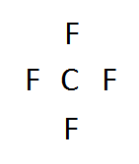*Molecules - Single Bonds*

1. Add up all the valence electrons of the atoms involved.  Example: CF4

* C has 4 and F has 7 (x 4, since we have 4 F’s) = 32 valence electrons

2. The central atom is typically the least electronegative element.

* C will be surrounded by F's in this case. (H is *never* the central atom.)
* Typical central atoms include C, N, P and S.
* Sometimes there is no one central atom (ex. C2H2). Just remember H is never in the center.

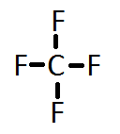3. Now we create our skeleton structure by drawing bonds in. A bond is a dash that represents 2 electrons.

* You can use dots, if you prefer.
* We have now placed 8 electrons as 4 bonds. We have 32 - 8= 24 more electrons to place.

4. Starting with the outer atoms, add the remaining electrons in pairs (“lone pairs”) until all the electrons have run out.

|  |  |  |  |  |
| --- | --- | --- | --- | --- |
| http://www.kentchemistry.com/links/bonding/covale3.gif | http://www.kentchemistry.com/links/bonding/covale4.gif | http://www.kentchemistry.com/links/bonding/covale5.gif | ==> | http://www.kentchemistry.com/links/bonding/covale6.gif |

All 32 electrons are now in place; count the dots around each F. Six dots and a bond (2 electrons) is 8. We have our octet. The carbon has 4 bonds (2 electrons) for its 8.

*Molecules - Double and Triple Bonds***:** Same rules apply until #4

1. Add up all the valence electrons of the atoms involved.  ex CO2

* C has 4 and O has 6 (x2 ) = 16 valence electrons

http://www.kentchemistry.com/links/bonding/covale7.gif2. Select the central atom. C will be surrounded by O's

http://www.kentchemistry.com/links/bonding/covale8.gif3. Now we create our skeleton structure by placing bonds in. A bond is a dash that represents 2 electrons.

* We have now placed 4 electrons as 2 bonds. We have 16 - 4 = 12 more to place.

4. Starting with the outer atoms add the remaining electrons in pairs until all the electrons have run out.

|  |  |  |  |  |
| --- | --- | --- | --- | --- |
| http://www.kentchemistry.com/links/bonding/covale9.gif | http://www.kentchemistry.com/links/bonding/covale10.gif | http://www.kentchemistry.com/links/bonding/covale11.gif | ==> | http://www.kentchemistry.com/links/bonding/covale12.gif |

* All 16 electrons are now in place - count the dots around each O. 6 dots and a bond (2 electrons) is 8. We have our octet.

BUT – you’ve run out of electrons, and the carbon has 2 bonds (2electrons) for its 4....? C does not have its stable octet.

* We need 8 for carbon, so move a pair of electrons from the O to between the C and O. It will share 2 pairs of electrons instead of 1. It now has a double bond instead of a single bond.

|  |  |  |
| --- | --- | --- |
| http://www.kentchemistry.com/links/bonding/covale13.gif | carbon has 6 electrons, so move 2 from the other oxygen | http://www.kentchemistry.com/links/bonding/covale14.gif |

http://www.kentchemistry.com/links/bonding/covale15.gifIf you have fulfilled all the octets of all of the atoms and STILL have electrons left over in your count, place them in pairs around the central atom as *lone pairs*.

* Orient the lone pairs as far away from each other as possible – electrons still repel.

Practice: Draw the Lewis structure for each molecule.

H2S PBr3 H2O

*Molecules - Exceptions to the Octet Rule*

Fewer than 8 electrons: Be needs 4 electrons to be stable; B needs 6 electrons.

Practice: Draw the Lewis structure for each molecule.

BeCl2 BF3

More than 8 electrons: Many central atoms contain unoccupied d-orbitals. These are atoms in the third period and below. Only the central atom will expand its valence. If you have extra electrons left over even after all octets are full, place them as lone pairs around the central atom – the lone pairs will now occupy those empty d-orbitals.

Practice: Draw the Lewis structure for each molecule.

XeCl2 (yes, I know) SF4 SF6

*Ions*

For positively charged ions, subtract the charge from the total valence electron count. (For instance, a charge of +1 means subtract 1 electron.) For negatively charged ions, add the charge to the total valence electron count.

* Draw a set of square brackets around your Lewis structure.
* Write the charge of the ion in the upper right hand corner, just outside the bracket.

Practice: Draw the Lewis structure for each ion.

OH-  CO32- NH4+

***Resonance***

Resonance structures are equivalent Lewis structures which show alternative arrangements of electrons. Such structures must be drawn when a single Lewis structure does not adequately represent the known bonding of a molecule. Resonance typically occurs in molecules that contain a multiple bond and the position of the bond can change.

Two or more resonance structures are drawn and are connected with double headed arrows. The arrows indicate the structures are resonance forms and the true structure of the molecule is believed to be a hybrid of the resonance structures.

2

1

3

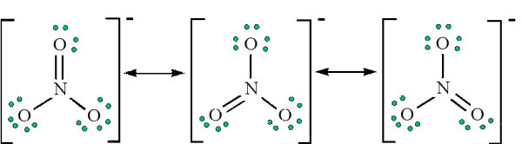

1

1

2

3

In the structure of nitrate the double bond occurs between the nitrogen and the oxygen number one, but why couldn’t it have formed between oxygen 3 and N. It could have and this is why there are resonance structures. In a structure with resonance, the double bond is actually longer than a normal double bond but is shorter than a normal single bond. The double bond is constantly rotating around all the positions it can form.

Practice

Draw all the resonance structures for carbonate.

More Lewis Structure Practice

|  |  |  |
| --- | --- | --- |
| **N2O** | **HCO31-**  Resonance  Resonance  Resonance  Resonance  Resonance | **SO42-**  Resonance |
| **C2H4** | **CO32-** | **O3** |
| **HNO3**  Resonance  Resonance  Resonance  Resonance  Resonance | **CO** | **BrO31-**  Resonance |
| **HCN** | **CH2S** | **PBr3** |

**6.6: VSEPR Activity and Practice**

**VSEPR Theory:** (**V**alence-**S**hell **E**lectron **P**air **R**epulsion)

* Repulsion between the valence electrons surrounding an atom causes these electrons to be oriented as far apart as possible. This determines the shape of the molecule.
* Molecular shape has deep implications for biology – for example, the shape of proteins often determine its function. Cell membrane receptors rely on correct shape to fit signal molecules correctly.
* Depending on the geometry of the molecule some molecules are polar or non-polar. A polar molecule is one in which there is an unequal distribution of molecules. Typically an unsymmetrical molecule will be polar. Also if there are any lone pairs on the central atom the molecule will be polar, except for few exceptions trigonal bipyramidal linear and square bipyrampidal square planar.

**(Model B is better because the valence electrons are further apart)**

Example: BF3

**Model A** **Model B**

F

F B F

90o

**Better model** -------> B

1200

F

F F

|  |  |  |  |  |  |  |
| --- | --- | --- | --- | --- | --- | --- |
| **VSEPR Worksheet (Complete with VSEPR Tutorial)** | | | | | | |
| **Electronic Structure**  **(Family)** | **Molecular Structure**  **(Geometry)** | **Areas of e- Density around central atom** | **# Of Bonds** | **# Of Lone Pairs** | **Bond Angles** | **Molecular Polarity \*** |
|  |  | **2** | **2** | **0** |  |  |
|  |  | **3** | **3** | **0** |  |  |
|  |  | **3** | **2** | **1** |  |  |
|  |  | **4** | **4** | **0** |  |  |
|  |  | **4** | **3** | **1** |  |  |
|  |  | **4** | **2** | **2** |  |  |
|  |  | **5** | **5** | **0** | **/** |  |
|  |  | **5** | **4** | **1** | **/** |  |
|  |  | **5** | **3** | **2** |  |  |
|  |  | **5** | **2** | **3** |  | **\*\*** |
|  |  | **6** | **6** | **0** |  |  |
|  |  | **6** | **5** | **1** |  |  |
|  |  | **6** | **4** | **2** |  | **\*\*** |

\* Note: This chart is filled in based on the assumption that everything attached to the central atom is the same. A molecule automatically become polar (unequal sharing of electrons) is more than one type of atom is attached to its center.

\*\* Note: Another general rule is that if there are any lone pairs on the central atom, the molecule is polar. This is an exception to that rule.

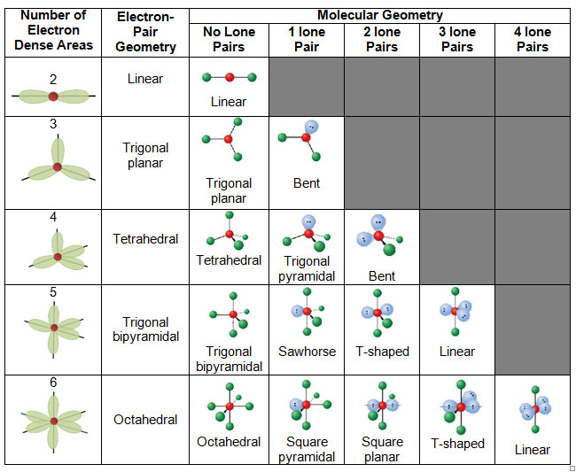

Figure 1https://www.google.com/url?sa=i&rct=j&q=&esrc=s&source=images&cd=&cad=rja&uact=8&ved=0ahUKEwjyg-io5pzSAhXFQiYKHRymAykQjRwIBw&url=http%3A%2F%2Fwww.intrepidpath.com%2Fmolecular-geometry-vsepr-theory-worksheet%2F&psig=AFQjCNH2SR5OTDNbMAR7aBhr0pb\_6f0KiQ&ust=

How can you determine the molecular geometry (shape) of a molecule? Keep in mind the following points:

* Localized regions of electrons around the central atom are called “areas of electron density.”
* Both lone pairs and bonding pairs count as areas of electron density.
* Multiple bonds count as one bond pair.

Steps:

1. Draw the Lewis structure.
2. Count the number of lone pairs and bond pairs on the central atom. (= areas of electron density). You can obtain a general shape from this number; this shape is called the *electron-dot geometry*.
3. Determine the number of lone pairs on the central atom. You can obtain the molecular geometry (shape) from this number.

Practice: Draw the Lewis structure for each molecule. Determine its molecular shape and predict if it is polar or nonpolar.

NF3 NO3-

ICl3 SbF5

|  |  |  |  |  |  |
| --- | --- | --- | --- | --- | --- |
| More VSEPR Practice  Practice: Build the following molecules using a model kit. Draw the Lewis structure for each molecule and determine its properties according to the chart. | | | | | |
| **Molecule** | **Lewis Structure** | **# Areas of e- density** | **Electron Structure (Family)** | **Molecular geometry** | **P or NP**  **Polarity** |
| **H2S** |  |  |  |  |  |
| **PCl3** |  |  |  |  |  |
| **CCl4** |  |  |  |  |  |
| **HCN** |  |  |  |  |  |
| **O3** |  |  |  |  |  |
| **BCl3** |  |  |  |  |  |
| **SCl4** |  |  |  |  |  |
| **ClO31-** |  |  |  |  |  |

**6.7: Percent Composition by Mass, Empirical and Molecular Formulas**

**Percent Composition**: law of constant composition states that *any sample of a pure compound always consists of the same elements combined in the same proportions by mass.*

*example:* If you have a box containing 100 golf balls and 100 ping pong balls, which type of ball contributes the most to the \_\_\_\_\_\_\_\_\_\_\_\_\_\_\_\_\_\_\_\_\_\_\_\_\_\_\_\_\_\_\_ of the box?

The same principle applies to finding the % composition of a compound. Different elements have different masses and this must be taken into consideration.

**Why DO chemists use it?**

**To figure out which compounds/molecules are the best sources of an element.**

What if I wanted to use potassium oxide as a source of oxygen? It would be helpful to know the % of oxygen in the compound.

Determining % composition is also a first step to determining the chemical formula of a new compound.

% comp = mass of desired x 100 Total mass

**Quick Lab: % Composition of Sweetener in Gum**

**Quick Lab: % Sweetener in Gum**

With your partners, design an experiment that you will perform to determine the % sweetener in a piece of gum. You have available: a piece of gum, a piece of weighing paper, and access to a balance.

Write your steps here:

Write your calculations here, and state the % of sweetener in your stick of gum here.

Look at the class data. What sources of error contribute to any differences in the data between groups?

**How to find the percent composition of a compound**

1. Write a correct formula for the compound.
2. Find the mass of the compound. (calculated from the periodic table)
3. Divide the total atomic mass of desired element by the molar mass of the compound.
4. Multiply by 100 to convert your results to a percent.
5. Express your answer to 3 decimal places and don’t forget the % sign.

Example 1: Calculate the percent composition of oxygen in potassium oxide.

Example 2: Calculate the percent composition of oxygen in copper (I) sulfate.

Which would be a better source of oxygen – potassium oxide or copper (I) sulfate?

Practice

1. Determine (to 3 sig fig's) the % composition for each element in the following substances:

a) Iron(II) Oxide b) Sodium Carbonate c) Magnesium Nitrate d) C4H10 e) Nitrogen

\_\_\_\_ \_\_\_\_ \_\_\_\_ \_\_\_\_ \_\_\_\_ \_\_\_\_ \_\_\_\_ \_\_\_\_ \_\_\_\_ \_\_\_\_ \_\_\_\_

Fe O Na C O Mg N O C H N

1. Calculate the percent composition by mass of each element in calcium carbonate.
2. Find the percent composition by mass of each element in magnesium nitrate.
3. Which is a better source of oxygen, silver (I) nitrate or dihydrogen monoxide? Use calculations to support your conclusion.

Empirical and Molecular Formula

[Empirical Formula](https://en.wikipedia.org/wiki/Empirical_formula): a formula is the simplest positive integer ratio of atoms present in a compound.[[1]](#footnote-1)

[Molecular formula](https://en.wikipedia.org/wiki/Chemical_formula#Molecular_formula): a formula of a compound in which the subscripts give the actual number of each element in the formula

Here are examples of molecular formulas:

|  |  |
| --- | --- |
| Molecular Formula | Empirical Formula |
| H2O | H2O |
| C2H4O2 | CH2O |
| CH2O | CH2O |
| C6H12O6 | CH2O |

Notice two things:

1. The molecular formula and the empirical formula can be \_\_\_\_\_\_\_\_\_\_\_\_\_\_\_\_\_.  
2. You scale up from the empirical formula to the molecular formula by a \_\_\_\_\_\_\_\_\_\_\_\_\_\_\_\_\_\_\_\_\_\_\_\_\_\_\_\_\_\_\_ factor.

**Why do chemists use it?**

Sometimes if an unknown substance is found the substance is analyzed and the relative ratios of each element can be determined, this will give the empirical formula. By knowing the empirical formula it can help to narrow down the exact compound/molecule.

How to CALCULATE Empirical Formulas

**1. Percent to mass  
2. Mass to mole  
3. Divide by small  
4. Multiply 'til whole**

1. If given the percentages of each element, assume 100 grams of the substance and convert % into grams.
2. Convert to moles by dividing the amount in grams by the molar mass of the element.
3. Select the smallest mole value and divide ALL values by this smallest one.
4. The results of Step 3 will either be VERY close to whole numbers or will be recognizable mixed number fractions. If any result from Step 3 is a decimal mixed number, you must multiply ALL values by some number to make it a whole number. Ex: 1.33 x 3, 2.25 x 4, 2.50 x 2, etc.

5. Use these whole number results as subscripts and write the empirical formula, listing the elements in the order they are given in the problem. (HINT: don’t be surprised in the subscripts in some formulas are VERY large-many organic molecules are huge)

Example:

A compound is 40.0 % C, 6.70 % H and 53.3 % O

|  |  |  |  |  |
| --- | --- | --- | --- | --- |
| 40.0% C🡪 40.0 g C | 1 mol C | 3.33 mol C**\*** | 1 mol C |  |
|  | 12.0 g C | 3.33 |  |  |
|  |  |  |  | Empirical Formula |
| 6.70% H 🡪 6.70 g H | 1 mol H | 6.65 mol H | 2 mol H | CH2O |
|  | 1.008 g H | 3.33 |  |  |
|  |  |  |  |  |
| 53.3% O 🡪 53.3 g O | 1 mol O | 3.33 mol O**\*** | 1 mol C |  |
|  | 16.0 g O | 3.33 |  |  |

\* smallest number of moles, divide everything by this.

**Practice**:

1. Find the empirical formula of a compound which contains 40.04% Ca, 12.00% C, and 47.96% O.
2. Find the empirical formula for a compound which contains 26.8% Sn, 16.0% Cl and 57.2% I.
3. A compound is 12.7% Al, 19.7% N, and 67.6% O. Determine its empirical formula.

**Molecular Formulas – are either the same as its experimentally determined empirical formula, or a multiple of the empirical formula.**

To determine the molecular formula, you must know the compound’s empirical formula AND the molar mass of the molecular compound.

How to Calculate the Molecular Formula

1. Calculate the molar mass of the empirical formula (EF) (which you have already found or it will be given to you )
2. Divide the known molar mass of the molecular formula (MF) by the mass of the empirical formula. This will give you a positive integer
3. Multiply that number by the subscripts of the empirical formula to get the subscripts of the molecular formula.

$$n=\frac{mass of MF}{mass of EF}$$

Ex: The molar mass of a compound is 181.50 g/mol and the empirical formula is C2HCl. What is the molecular formula?

1. Find the mass of the EF.

Mass of EF = 60.49 g

1. Calculate multiplier n.
$$n=\frac{181.50}{60.49}=3$$

2. Multiply all the subscripts by n.

**C6H3Cl3**

Practice:

1. Find the empirical formula for a compound containing only carbon and hydrogen if it is known to contain 84.21% carbon. If the molar mass is 114 g/mol, what is the molecular formula of this compound?
2. Boron hydrides, compounds containing only boron and hydrogen, forma a large class of compounds. One consists of 78.14% B. The molar mass is 27.7 g/mol. What are the empirical and molecular formulas of this compound?
3. A compound with the following composition has a molar mass of 60.10g/mol: 39.97% carbon; 13.41% hydrogen; 46.62% nitrogen. Find the molecular formula.

**More Practice**

1. Draw the dipoles on each molecule. Identify each molecule as polar or nonpolar. 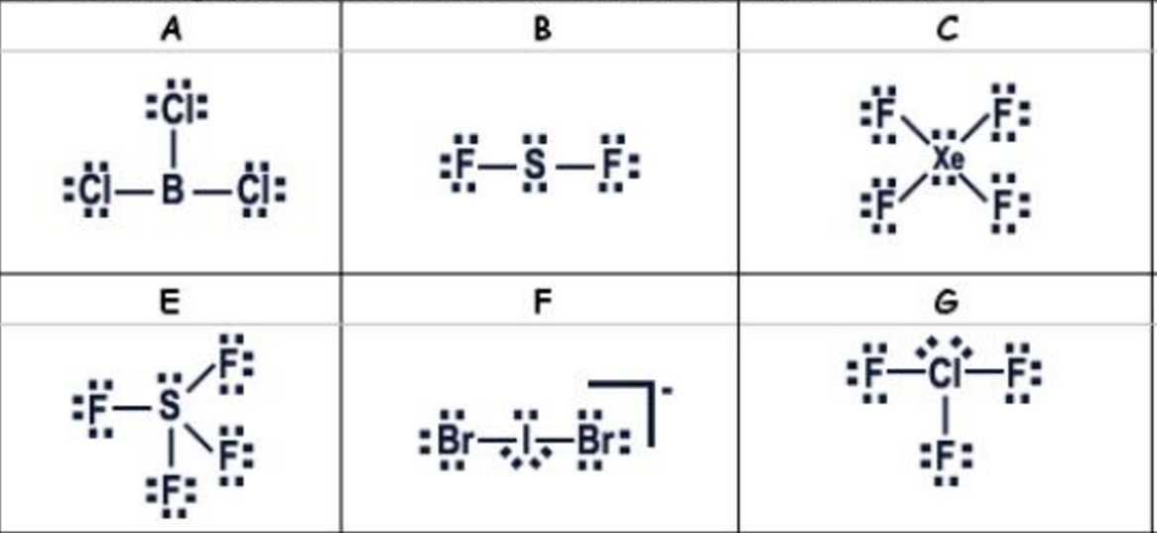

(Don’t worry about the letters.)

2. Write the formula or the name for each covalent compound.

a) antimony tribromide \_\_\_\_\_\_\_\_\_\_\_\_\_\_\_\_\_\_\_\_\_\_\_\_\_\_\_\_\_\_\_\_\_\_

b) P4S5 \_\_\_\_\_\_\_\_\_\_\_\_\_\_\_\_\_\_\_\_\_\_\_\_\_\_\_\_\_\_\_\_\_\_\_\_\_\_\_\_\_\_\_\_\_\_\_

c) chlorine dioxide \_\_\_\_\_\_\_\_\_\_\_\_\_\_\_\_\_\_\_\_\_\_\_\_\_\_\_\_\_\_\_\_\_\_\_\_\_\_

d) SeF6 \_\_\_\_\_\_\_\_\_\_\_\_\_\_\_\_\_\_\_\_\_\_\_\_\_\_\_\_\_\_\_\_\_\_\_\_\_\_\_\_\_\_\_\_\_\_\_

1. Draw the Lewis structure for each atom, molecule or ion.

a) N b) BF3

c) BF3 d) AsBr3

e) SO42- f) XeF5+

Draw the Lewis structure for each molecule. Predict its molecular shape. State if it is polar or nonpolar.

a) CF4 b) AsCl3

c) PBr5 d) XeF4

Write the correct formula, or the name, for each ionic compound.

a) ammonium chloride \_\_\_\_\_\_\_\_\_\_\_\_\_\_\_\_\_\_\_\_\_\_\_\_\_\_\_\_\_\_\_\_\_\_\_\_\_

b) CaCO3 \_\_\_\_\_\_\_\_\_\_\_\_\_\_\_\_\_\_\_\_\_\_\_\_\_\_\_\_\_\_\_\_\_\_\_\_\_\_\_\_\_\_\_\_\_\_\_\_\_

c) manganese (II) hydroxide \_\_\_\_\_\_\_\_\_\_\_\_\_\_\_\_\_\_\_\_\_\_\_\_\_\_\_\_\_\_\_\_\_

d) PbSO4 \_\_\_\_\_\_\_\_\_\_\_\_\_\_\_\_\_\_\_\_\_\_\_\_\_\_\_\_\_\_\_\_\_\_\_\_\_\_\_\_\_\_\_\_\_\_\_\_\_\_

e) potassium chromate \_\_\_\_\_\_\_\_\_\_\_\_\_\_\_\_\_\_\_\_\_\_\_\_\_\_\_\_\_\_\_\_\_\_\_\_\_

f) AgF \_\_\_\_\_\_\_\_\_\_\_\_\_\_\_\_\_\_\_\_\_\_\_\_\_\_\_\_\_\_\_\_\_\_\_\_\_\_\_\_\_\_\_\_\_\_\_\_\_\_\_\_

1. Compare and contrast the structure and properties of an ionic bond to those of a metallic bond.

2. Write the correct formula or the correct name for each acid or hydrate.

a) nitric acid \_\_\_\_\_\_\_\_\_\_\_\_\_\_\_\_\_\_\_\_\_\_\_\_\_\_\_\_

b) barium chloride dihydrate \_\_\_\_\_\_\_\_\_\_\_\_\_\_\_\_\_\_\_\_\_\_\_\_\_\_\_\_\_\_

c) BeSO4 · 4 H2O \_\_\_\_\_\_\_\_\_\_\_\_\_\_\_\_\_\_\_\_\_

d) H2C2O4 \_\_\_\_\_\_\_\_\_\_\_\_\_\_\_\_\_\_\_\_\_\_\_\_\_\_\_\_\_\_\_\_\_\_\_\_\_

e) magnesium nitrate heptahydrate \_\_\_\_\_\_\_\_\_\_\_\_\_\_\_\_\_\_\_\_\_\_\_\_\_\_\_\_\_\_

f) HClO2 \_\_\_\_\_\_\_\_\_\_\_\_\_\_\_\_\_\_\_\_\_\_\_

Calculate each quantity.

1. Calculate the percent composition by mass of each element in acetic acid. (Hint: write a formula

first.)

2. A compound contains 47.08% carbon, 6.59% hydrogen, and 46.33% chlorine by mass. The molar

mass of the compound is 153 g/mol. What are the empirical and molecular formulas of the

compound?

1. https://en.wikipedia.org/wiki/Empirical\_formula [↑](#footnote-ref-1)